# System Design Interview

If you are not preparing for most common questions, you are not preparing for interviews.

How to answer a question –

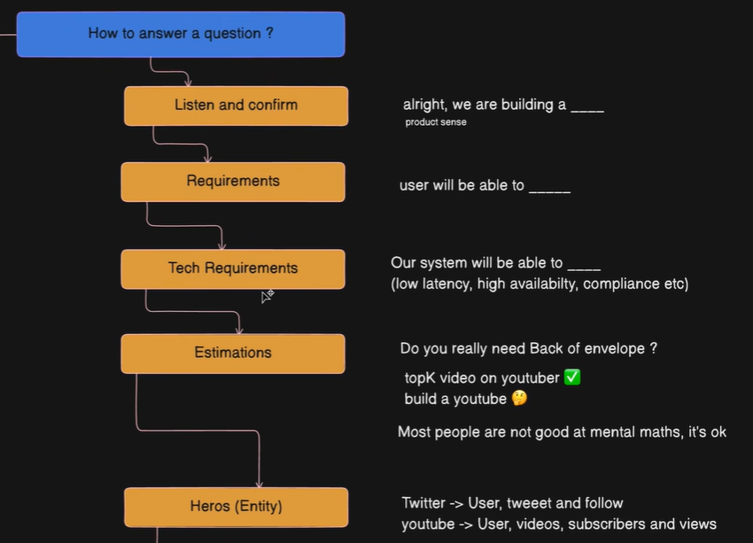

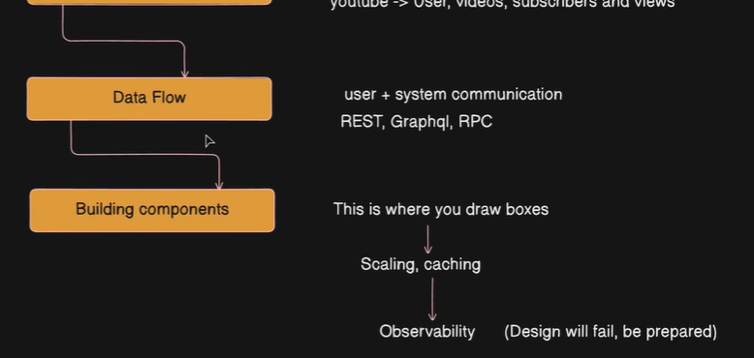

# System Design

Back of Envelope calculation – it is better to be roughly right than precisely wrong (directionally correctness). Below result (total addressable market or TAM) –

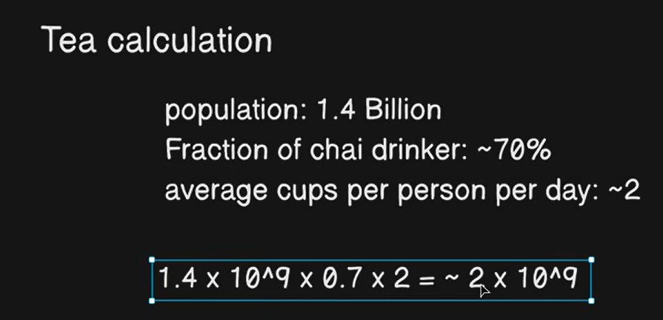

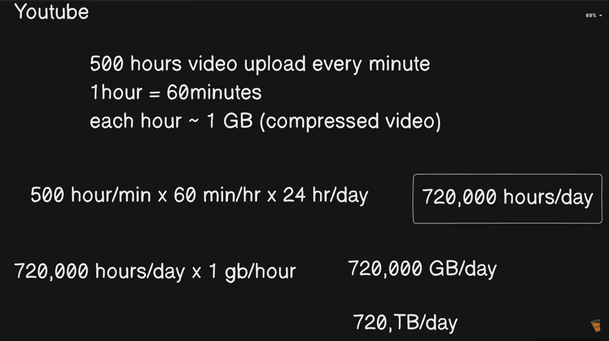

DAU (daily addressable users) –

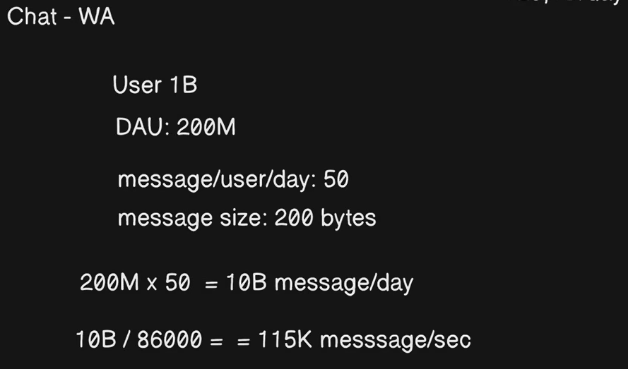

Agentic AI vs. AI Agents –

LLM (information) + action => agents

Agents have autonomy, they can plan, iterate and feedback unlike LLM which can only do planning.

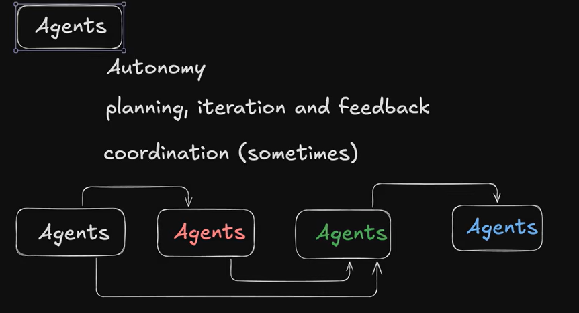

Base components of an Agent – tool is like API call –

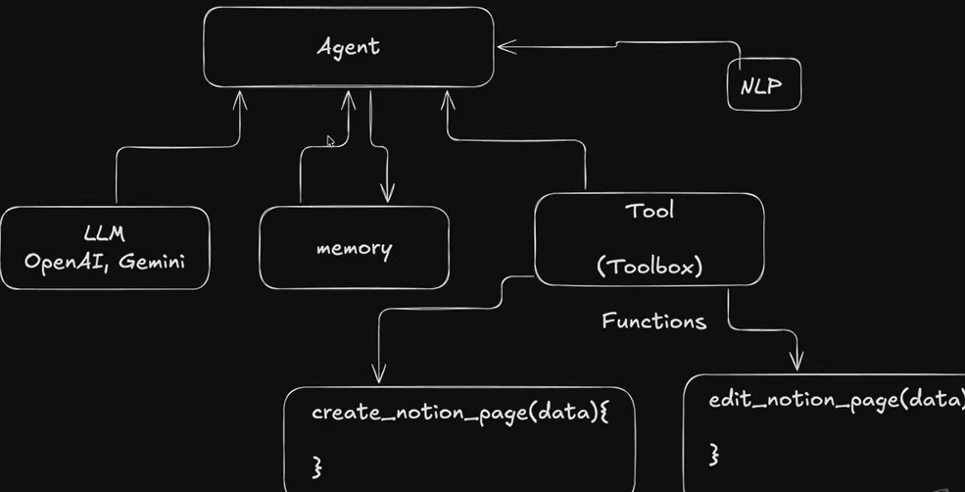

Agentic workflow –

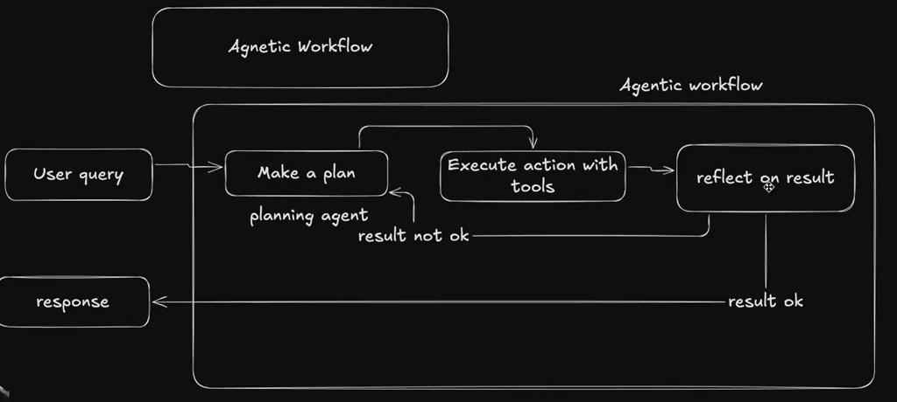

Multi-agent workflow –

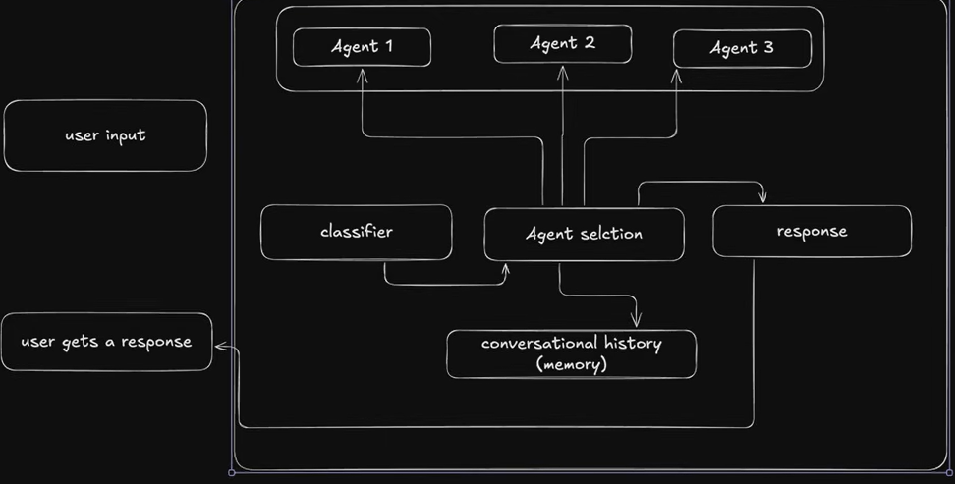

Main work of GenAi is for content creation, for agentic AI is to decision making and execution (tools).

Kafka decouples producers from consumers, letting theme evolve independently without breaking each other. Traffic spikes that overwhelm a direct connection get absorbed by log.

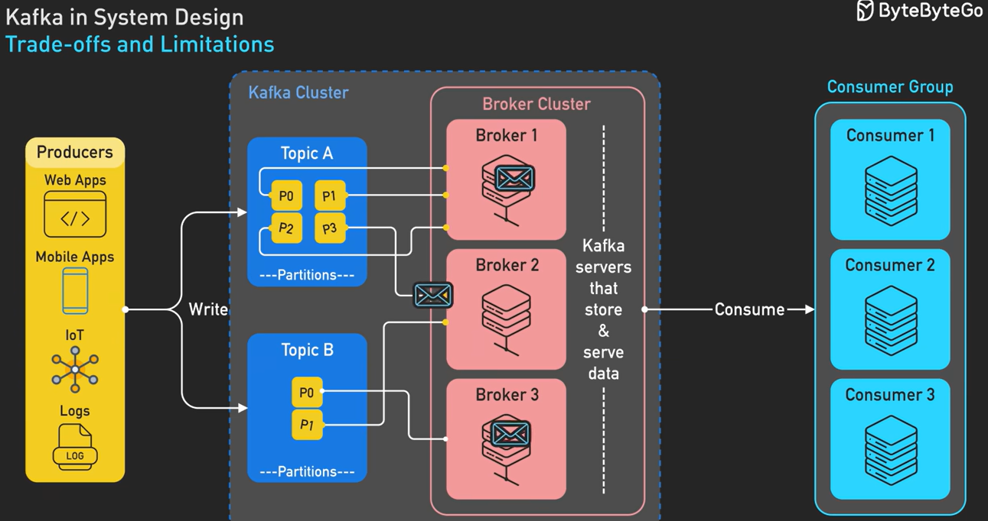

# System Design

Virtualization vs. containerization –

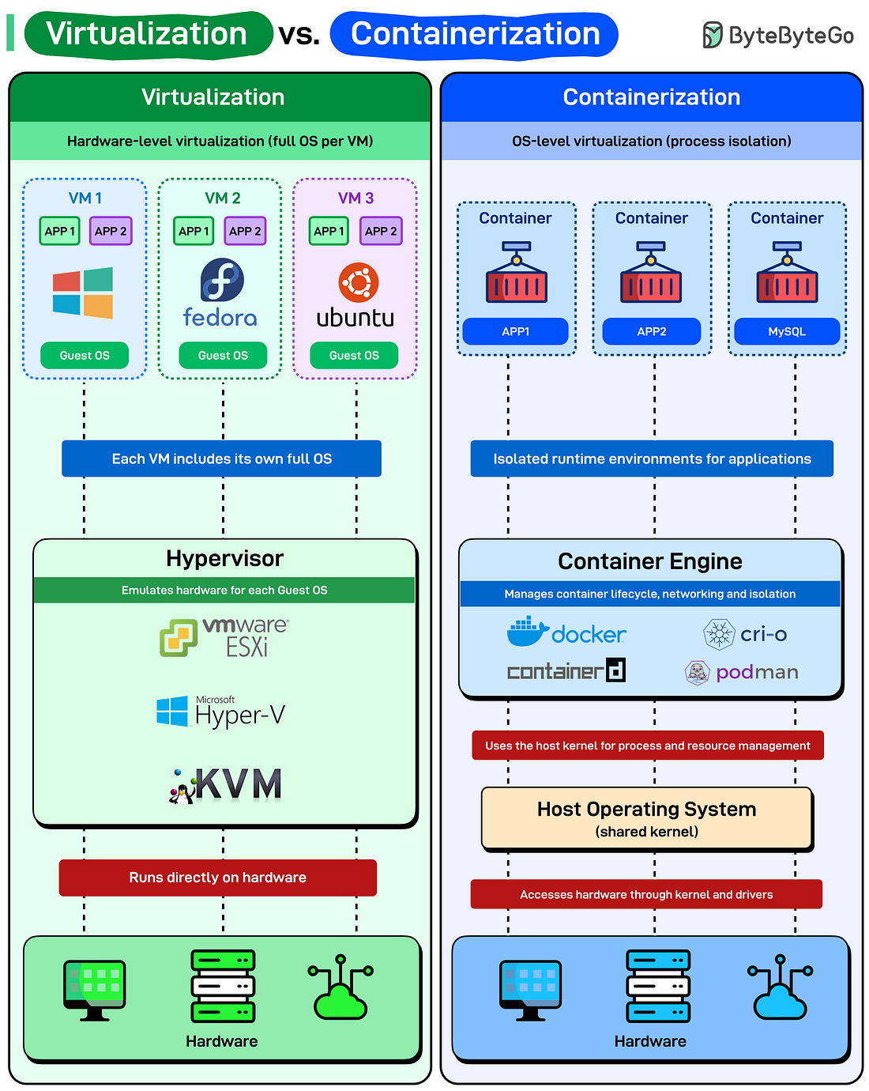

5 REST API authentication methods –

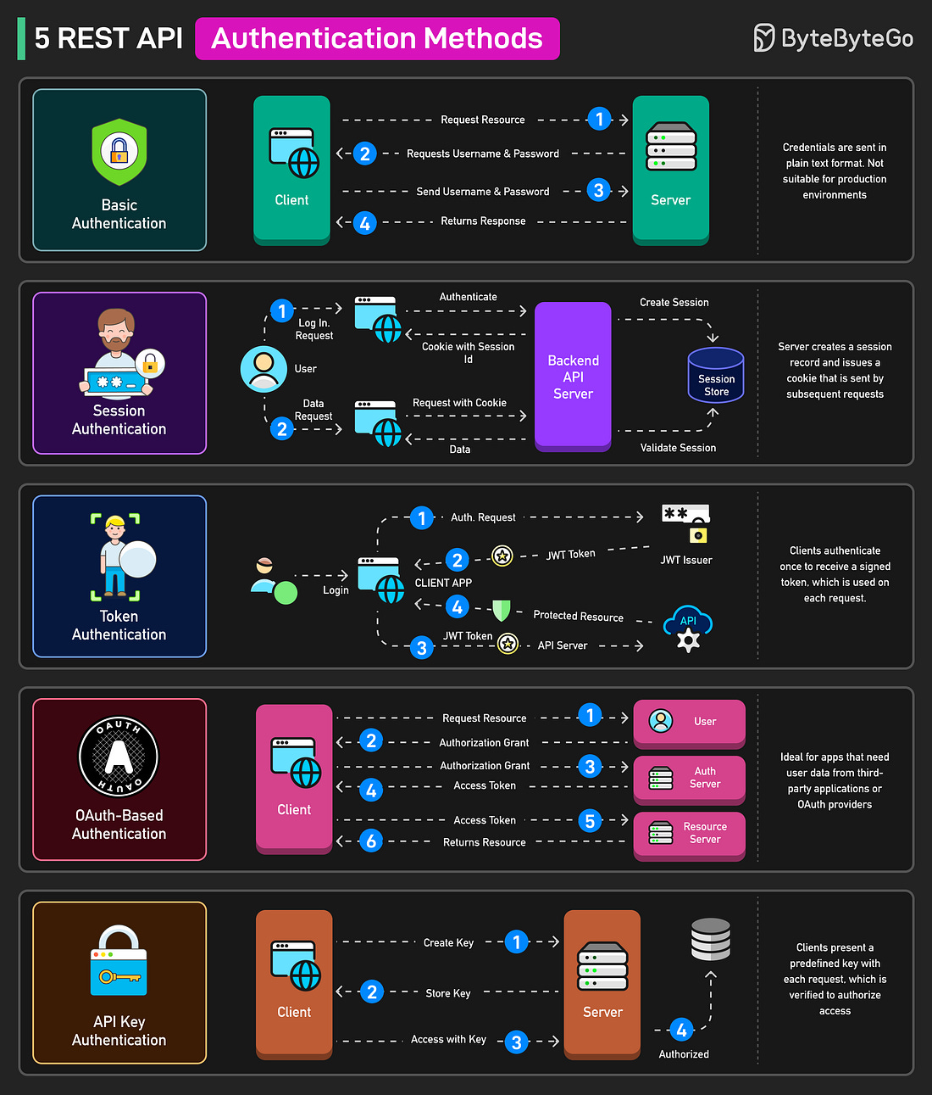

What is Firewall –

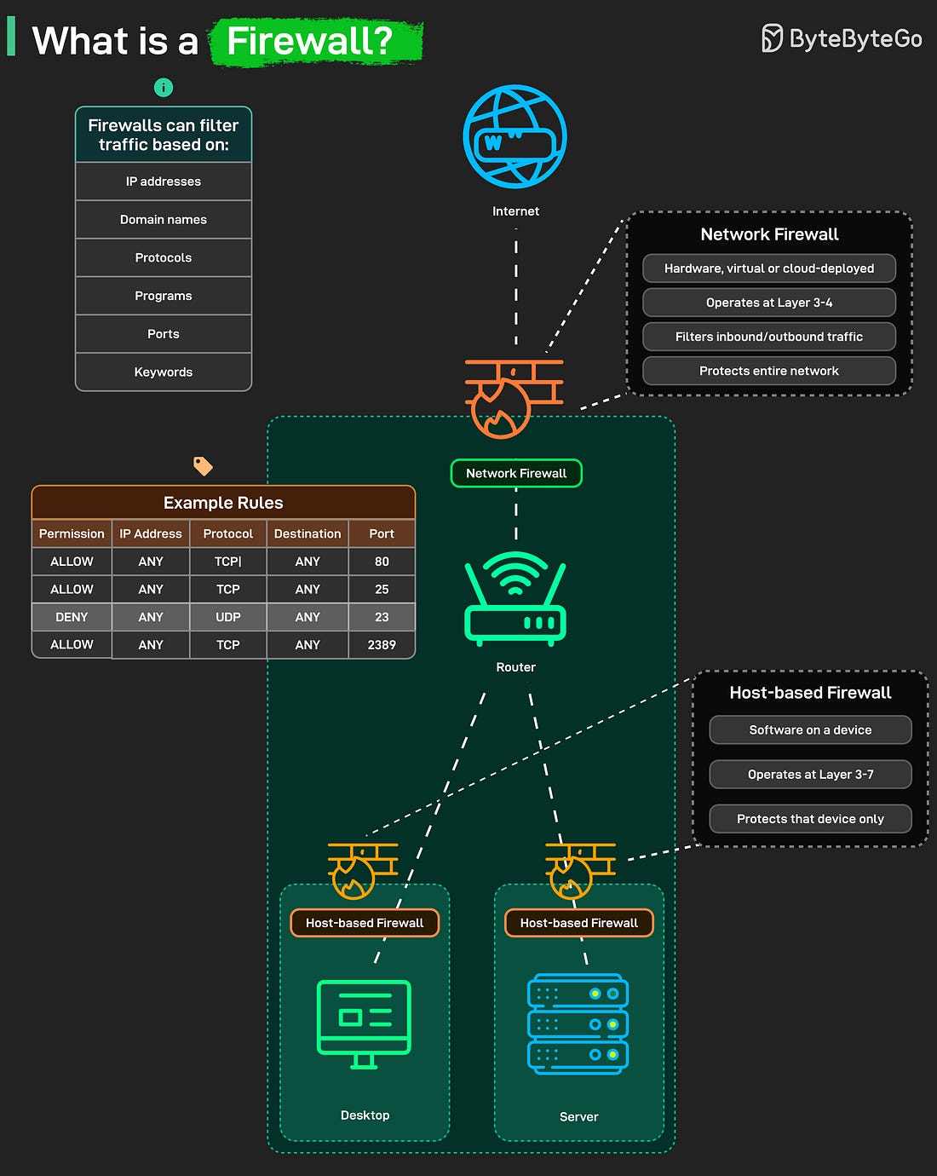

Modem vs. router –

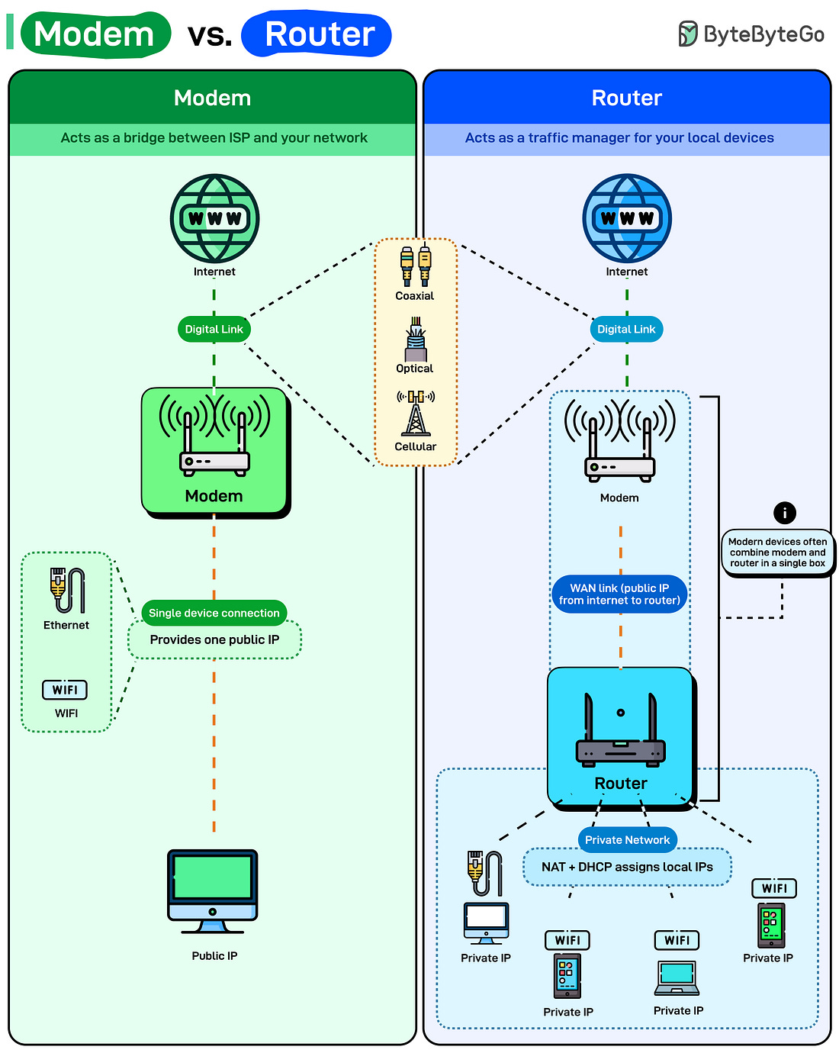

Top strategies to build high-availability systems –

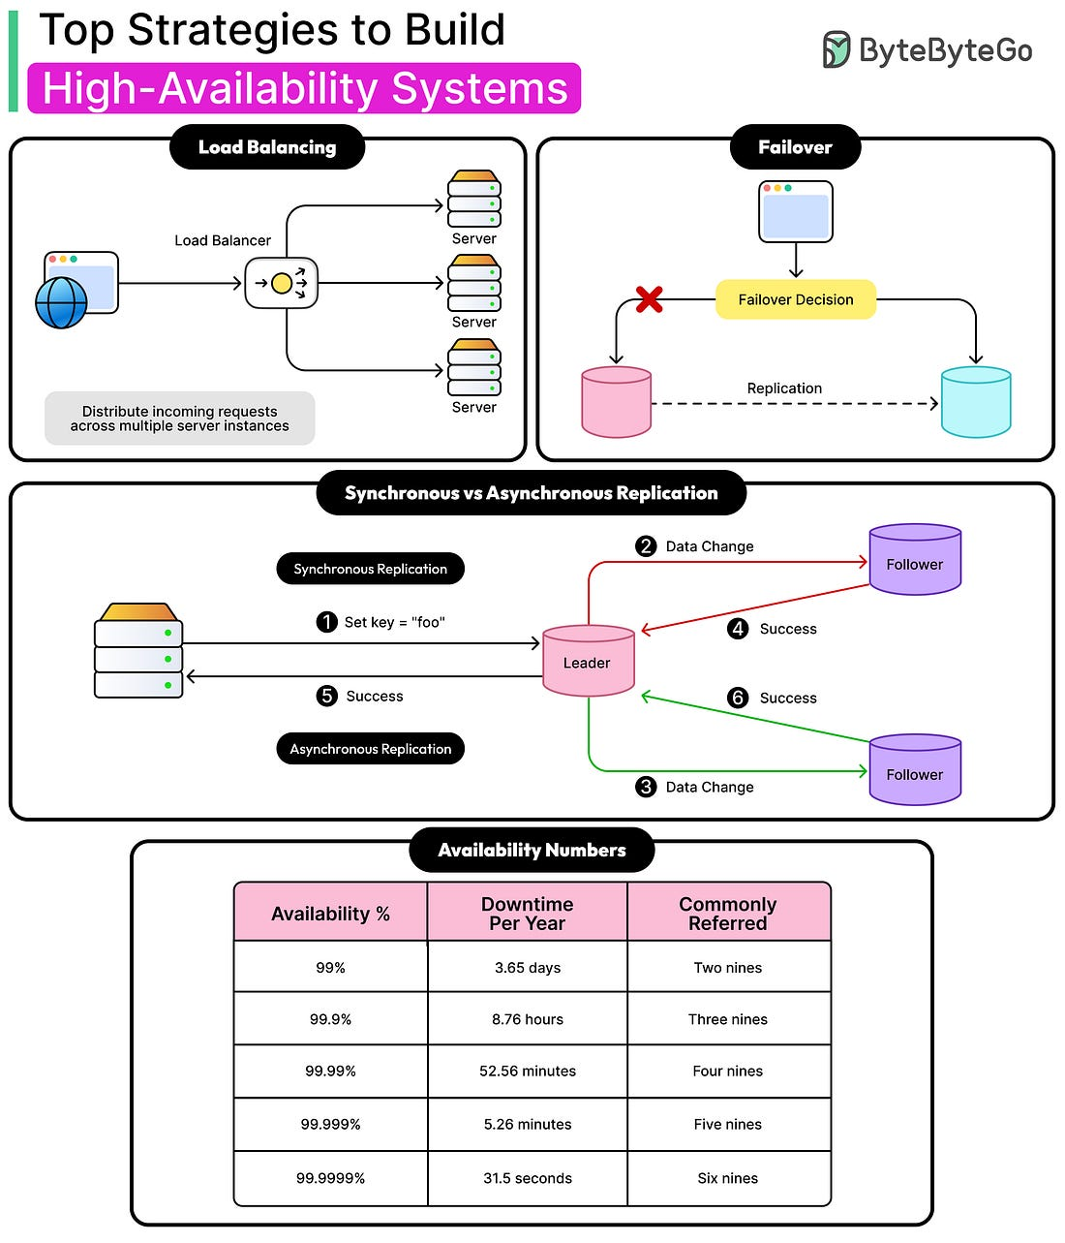

Orchestration vs. choreography –

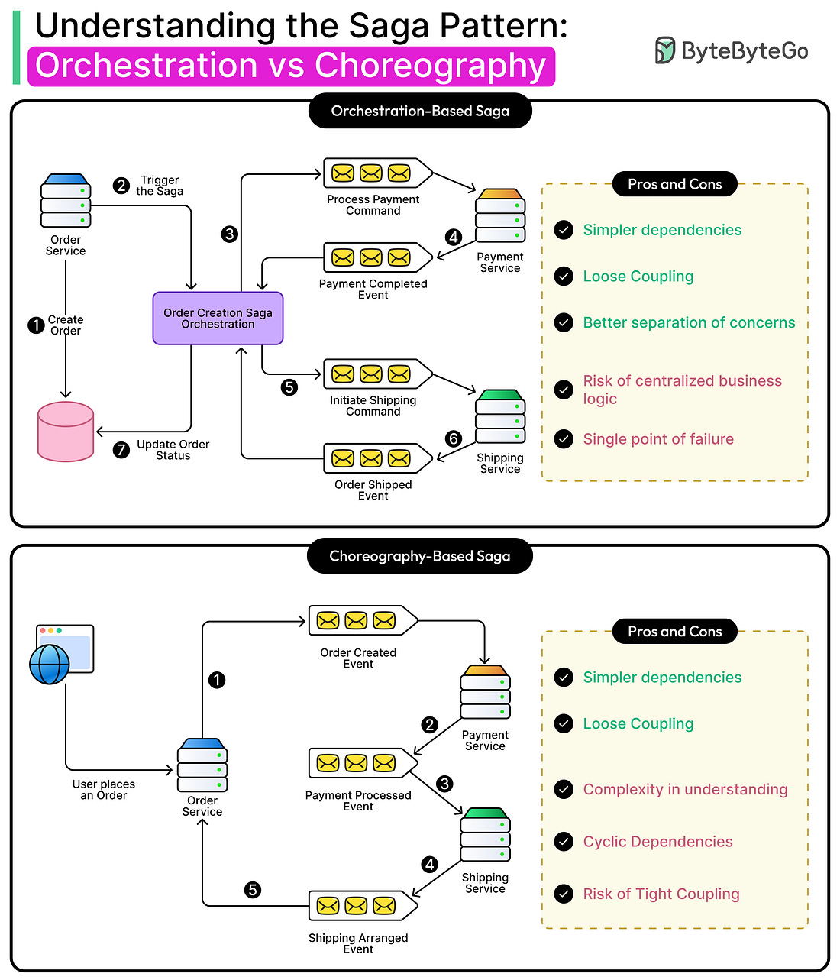

Cloudflare vs. AWS. Vs. Azure –

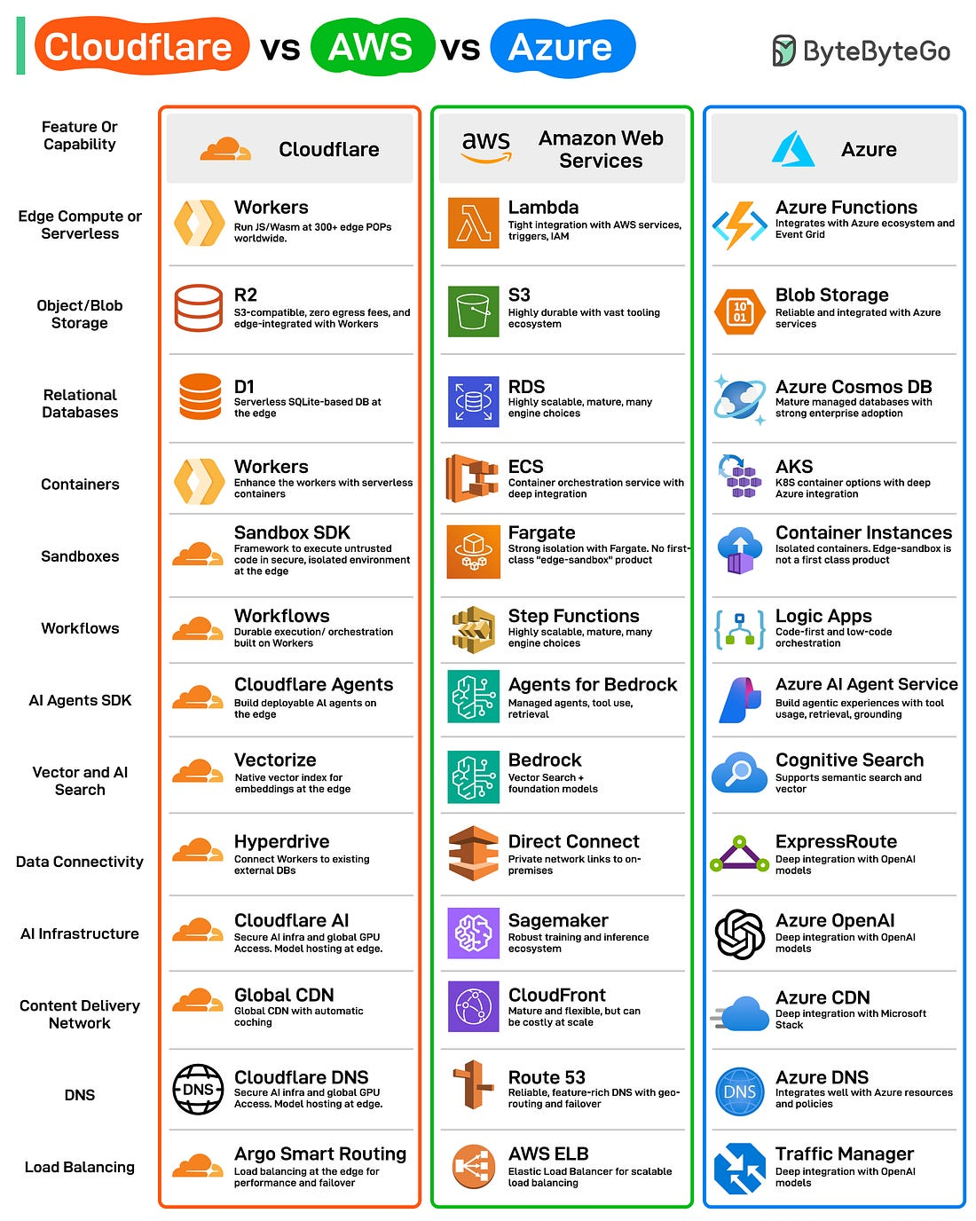

The backend tech stack –

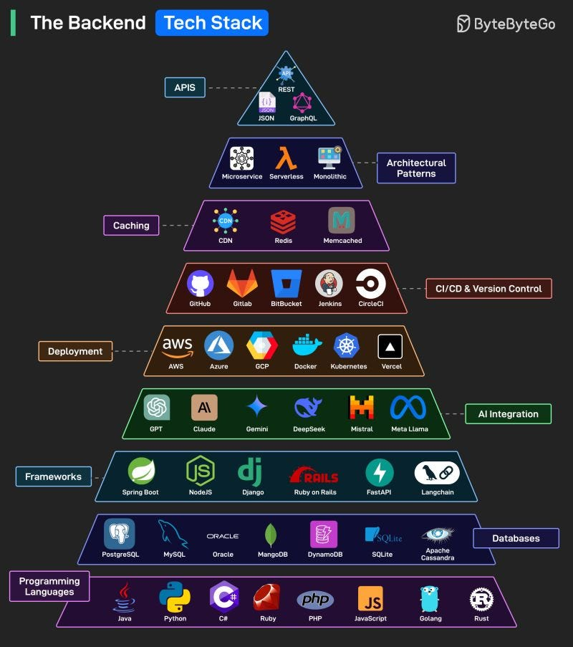

HTTP vs. HTTPS

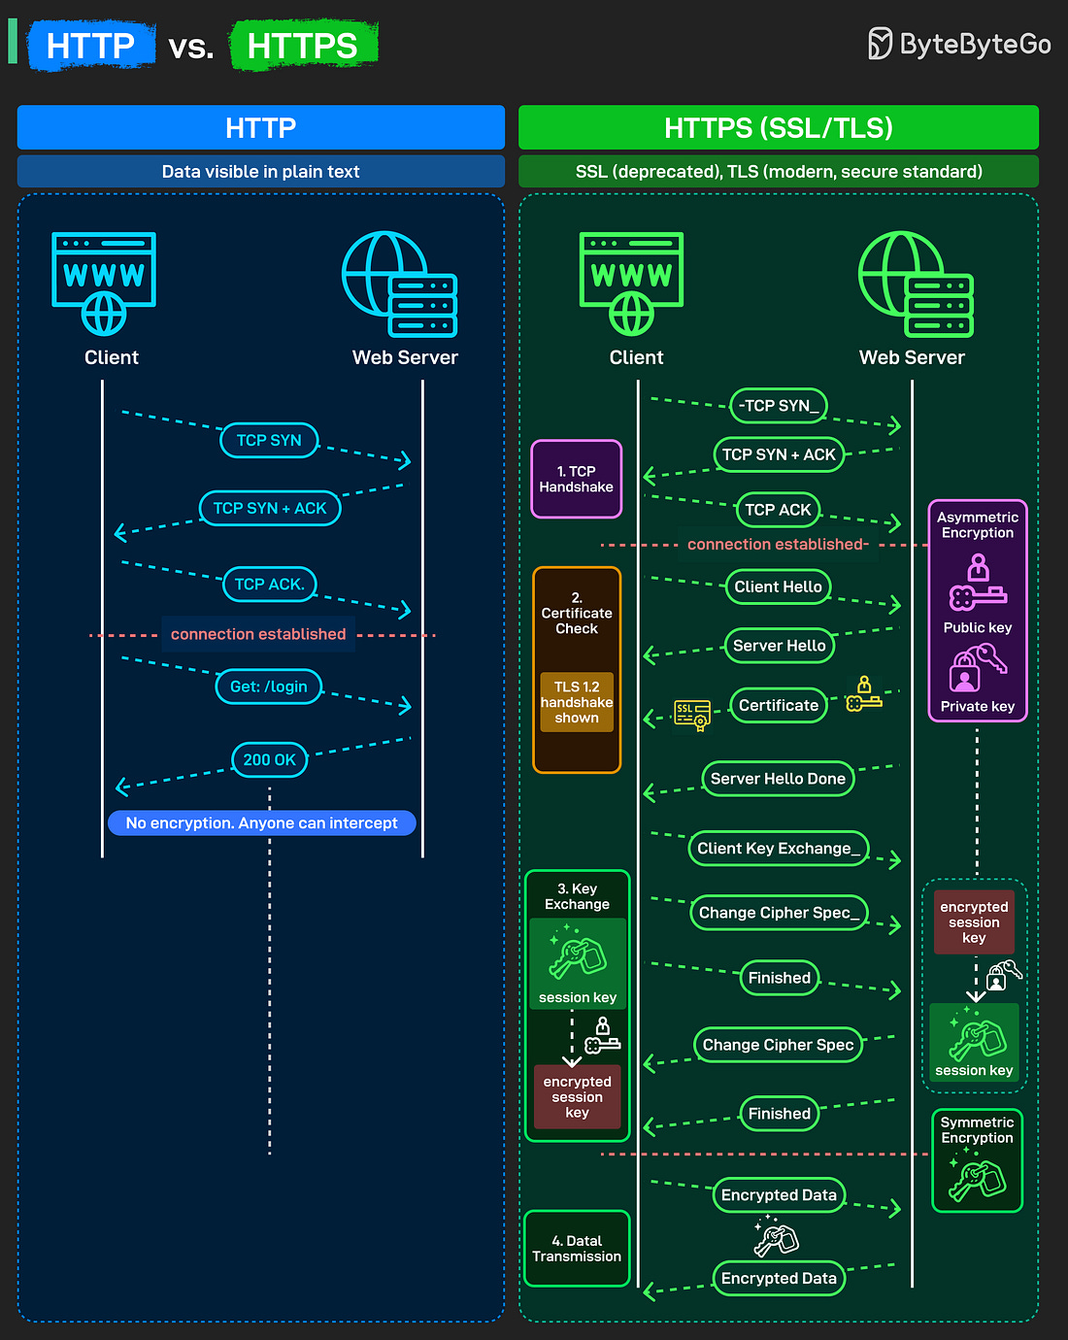

Forward proxy vs. reverse proxy –

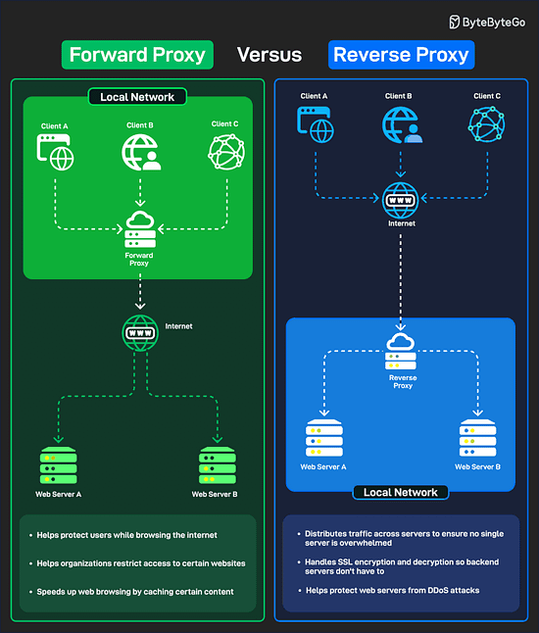

Top scalability pattens –

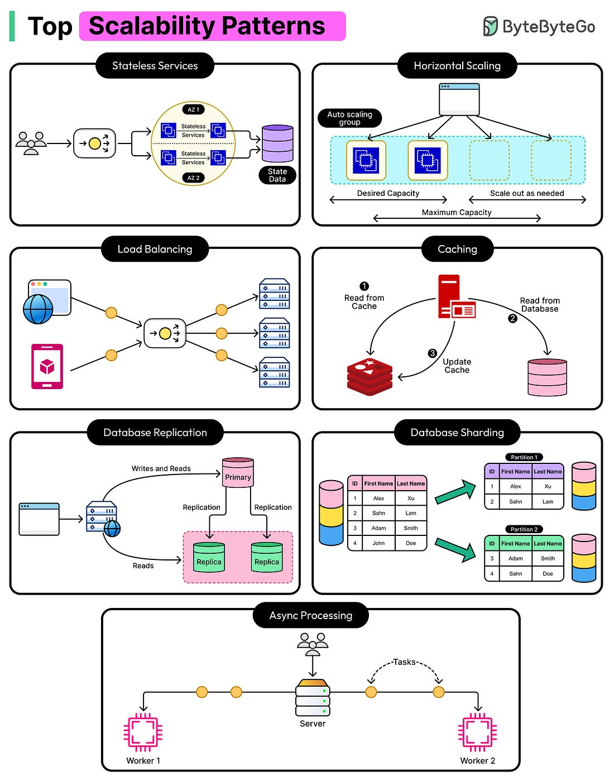

Top strategies to build high-availability systems –



How to Design Good APIs

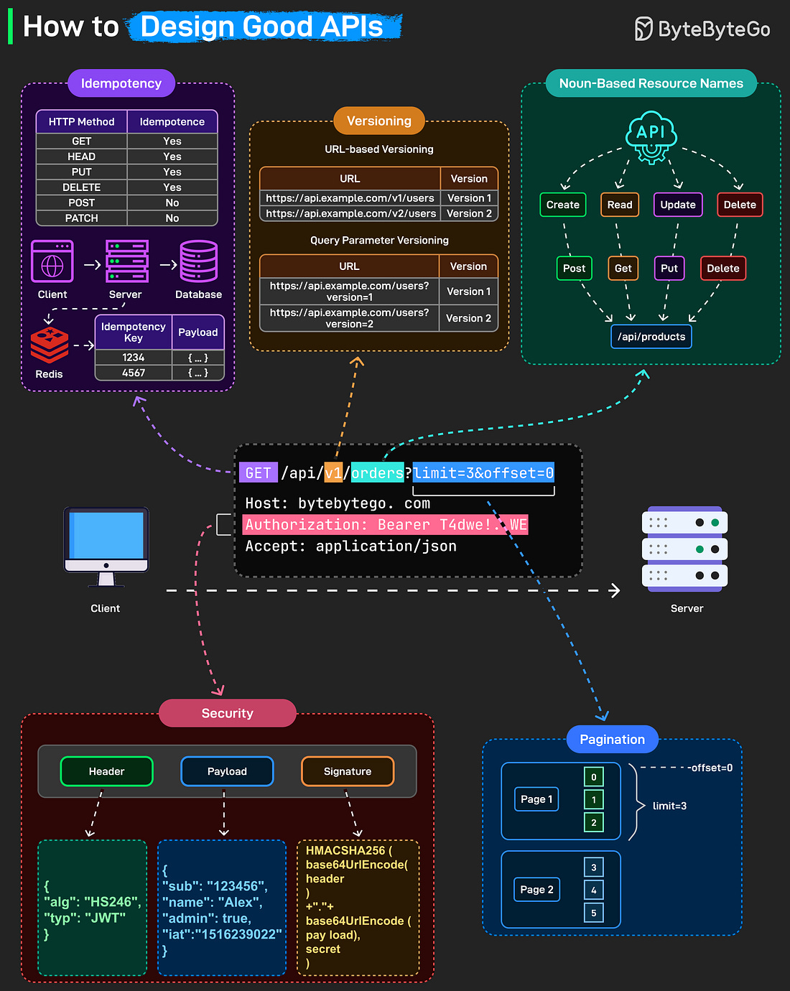

Big data pipeline cheat sheet for AWS, Azure and GCP –

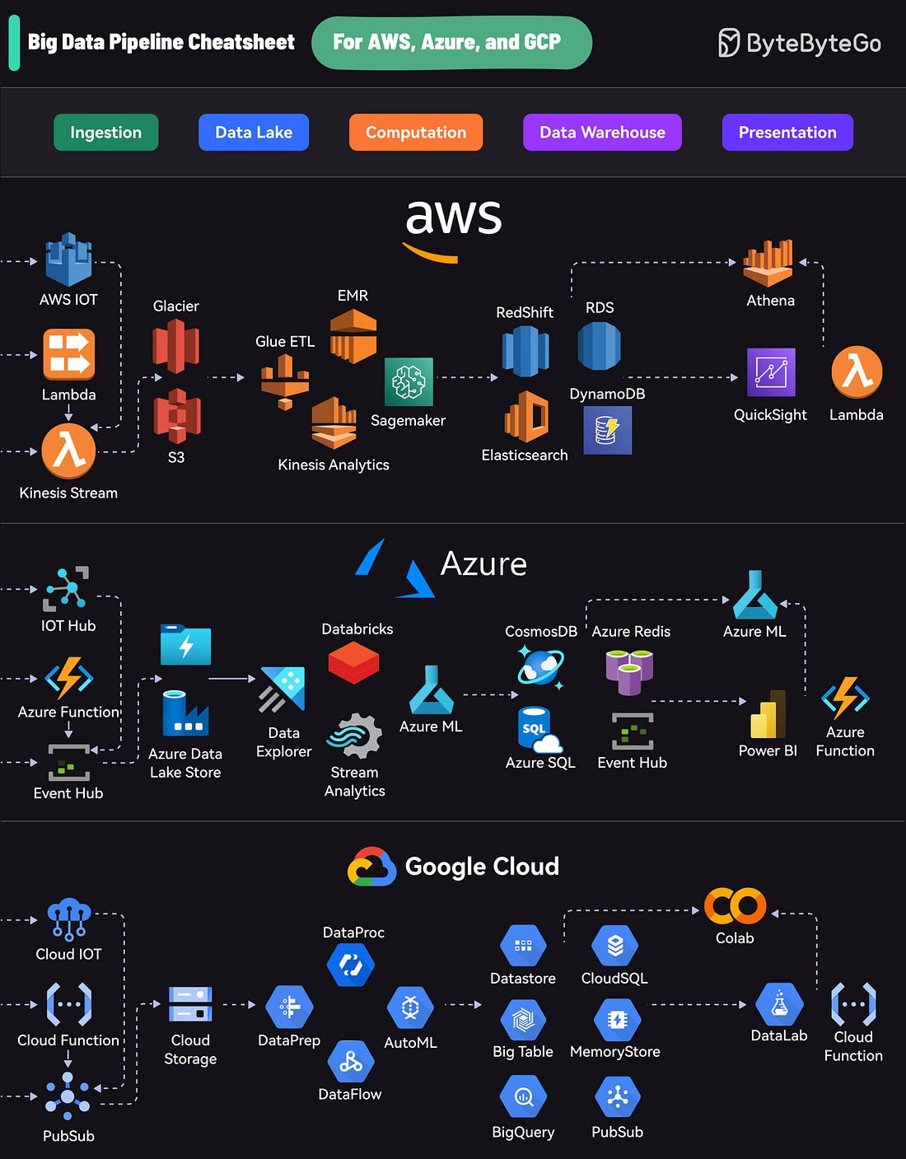

How to learn AWS –

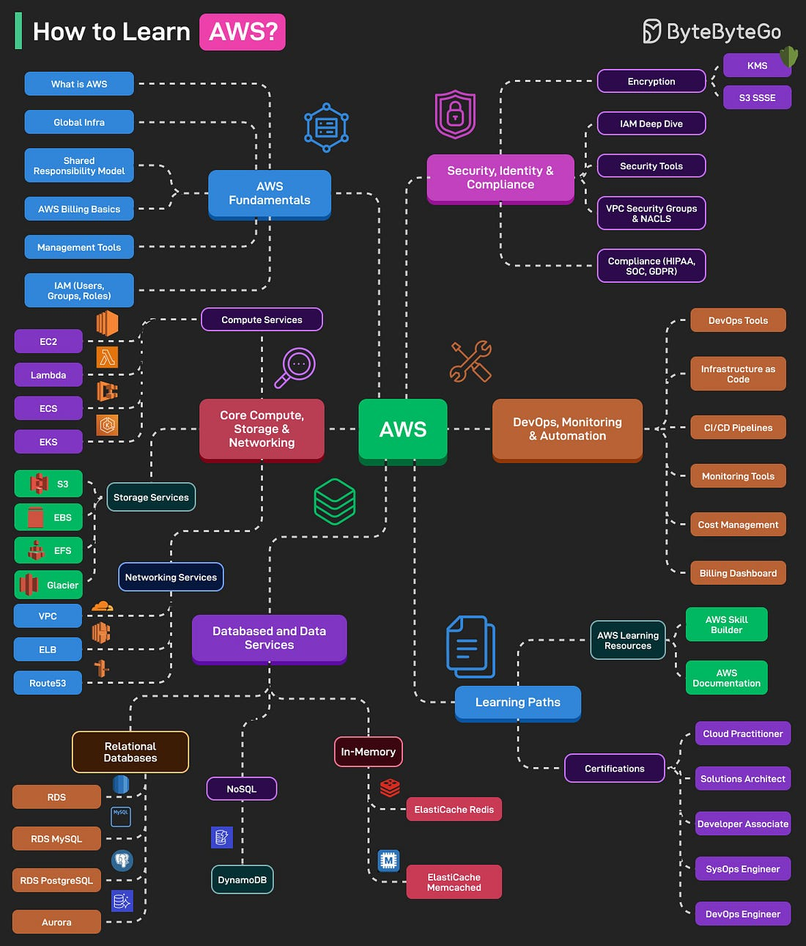

AI Agent tech stack –

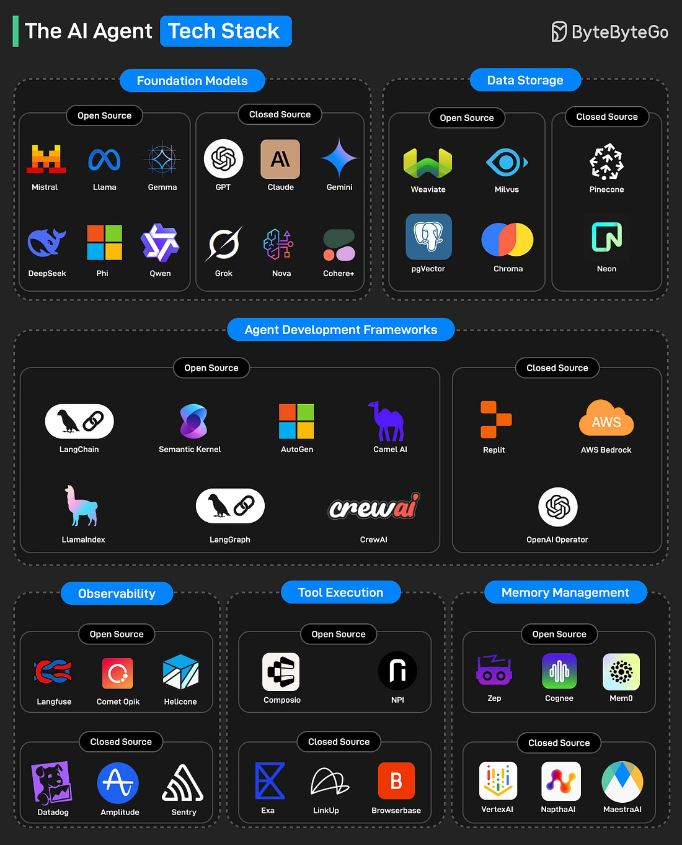

How to build a basic RAG application on AWS –

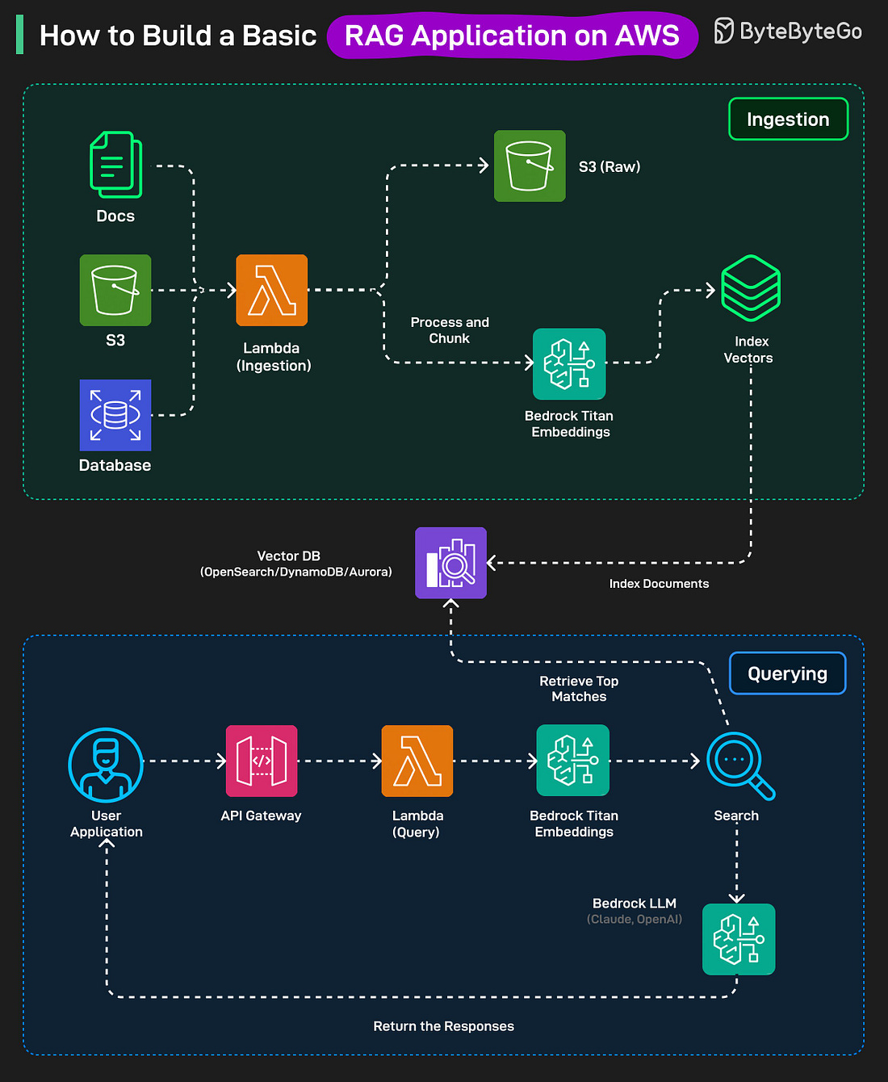

4 types of virtualization –

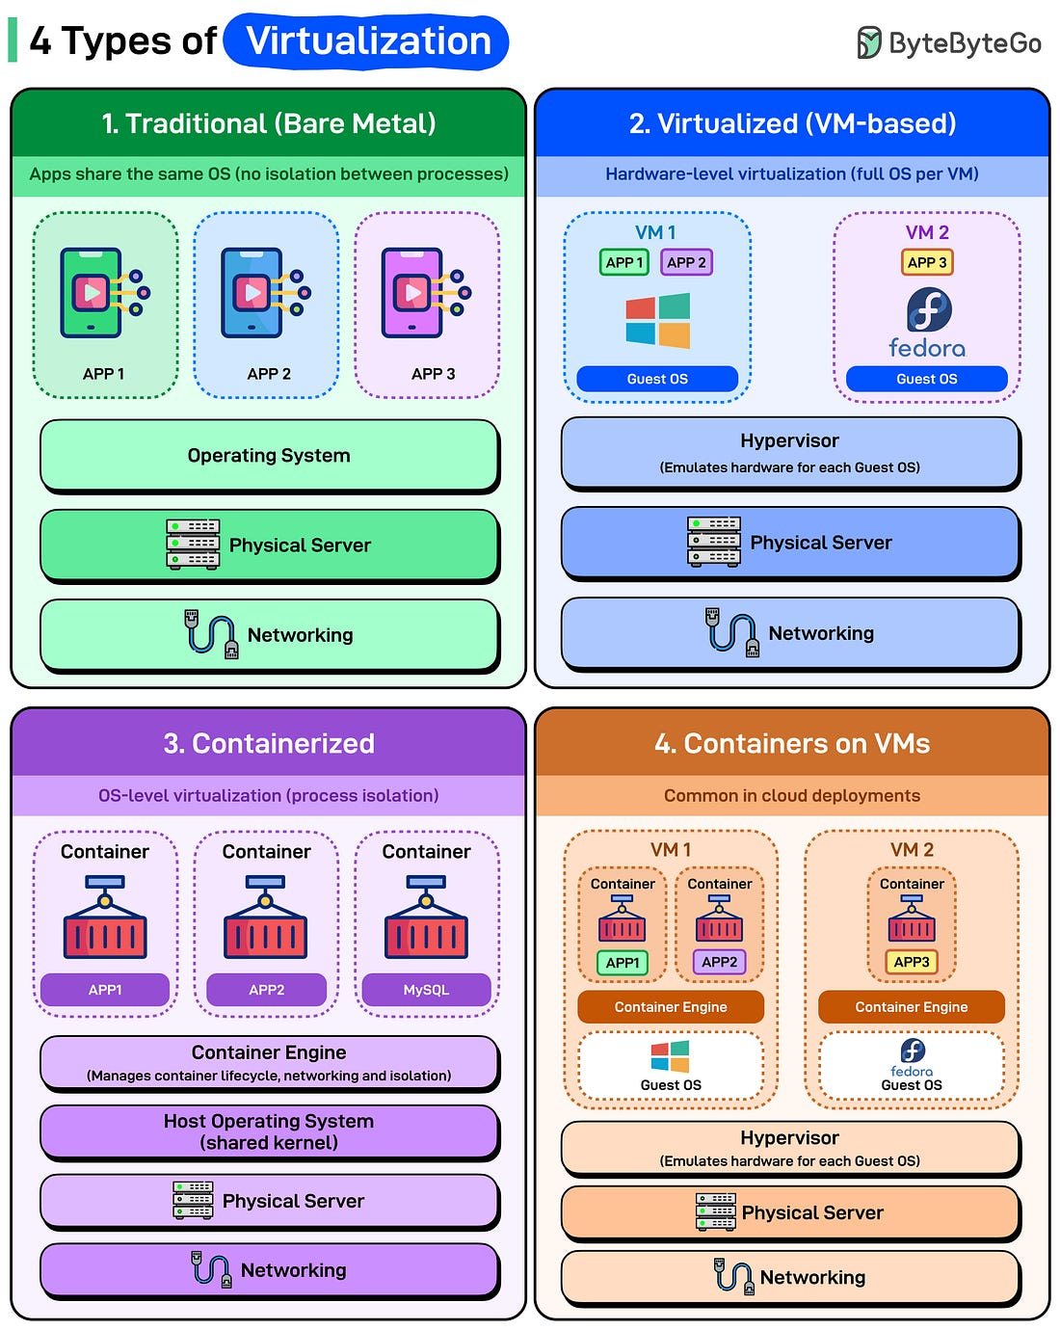

# System Design

Rate limiter –

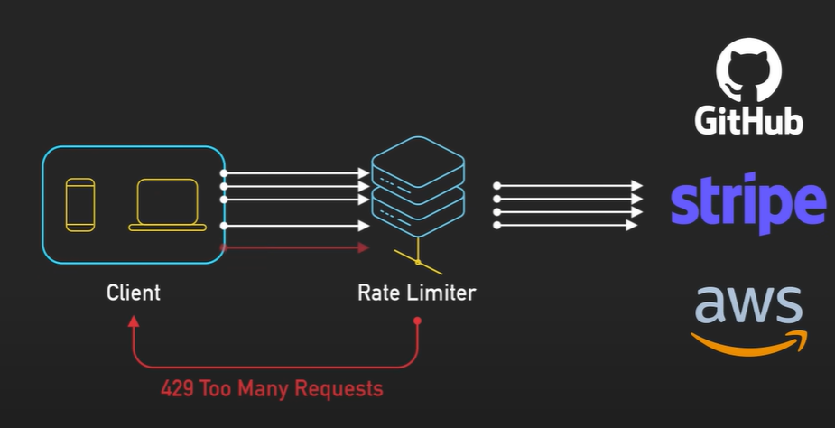

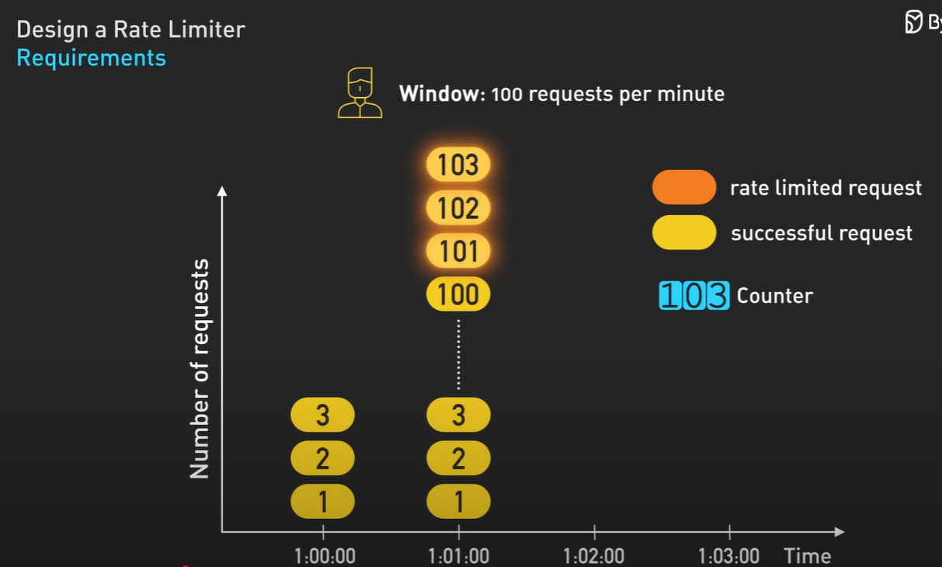

We can’t store each minute counters with requests counts in database as it is slow, we can use in-memory database like Redis –

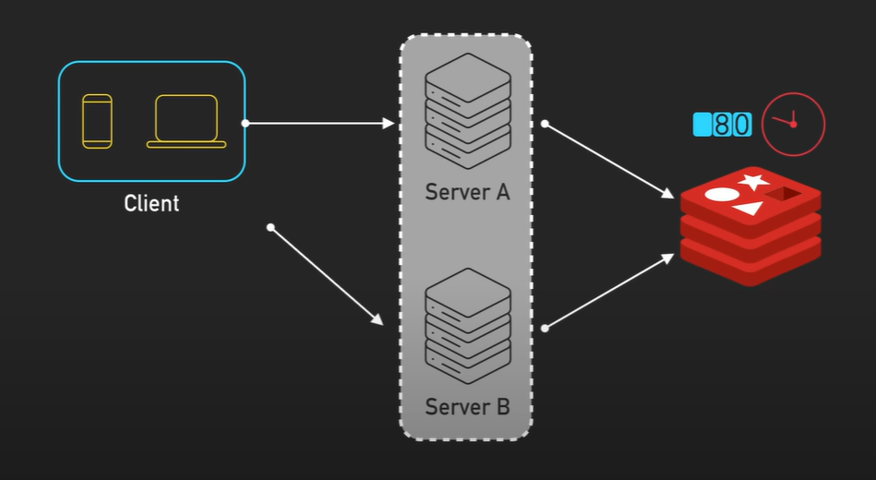

It also has window boundary problem which can be eliminated by using AWS stripe, it uses token bucket algorithm, we can have another algorithm for same problem to solve like Sliding Window Logs, Sliding Window Counters, Leaky Bucket Algorithm –

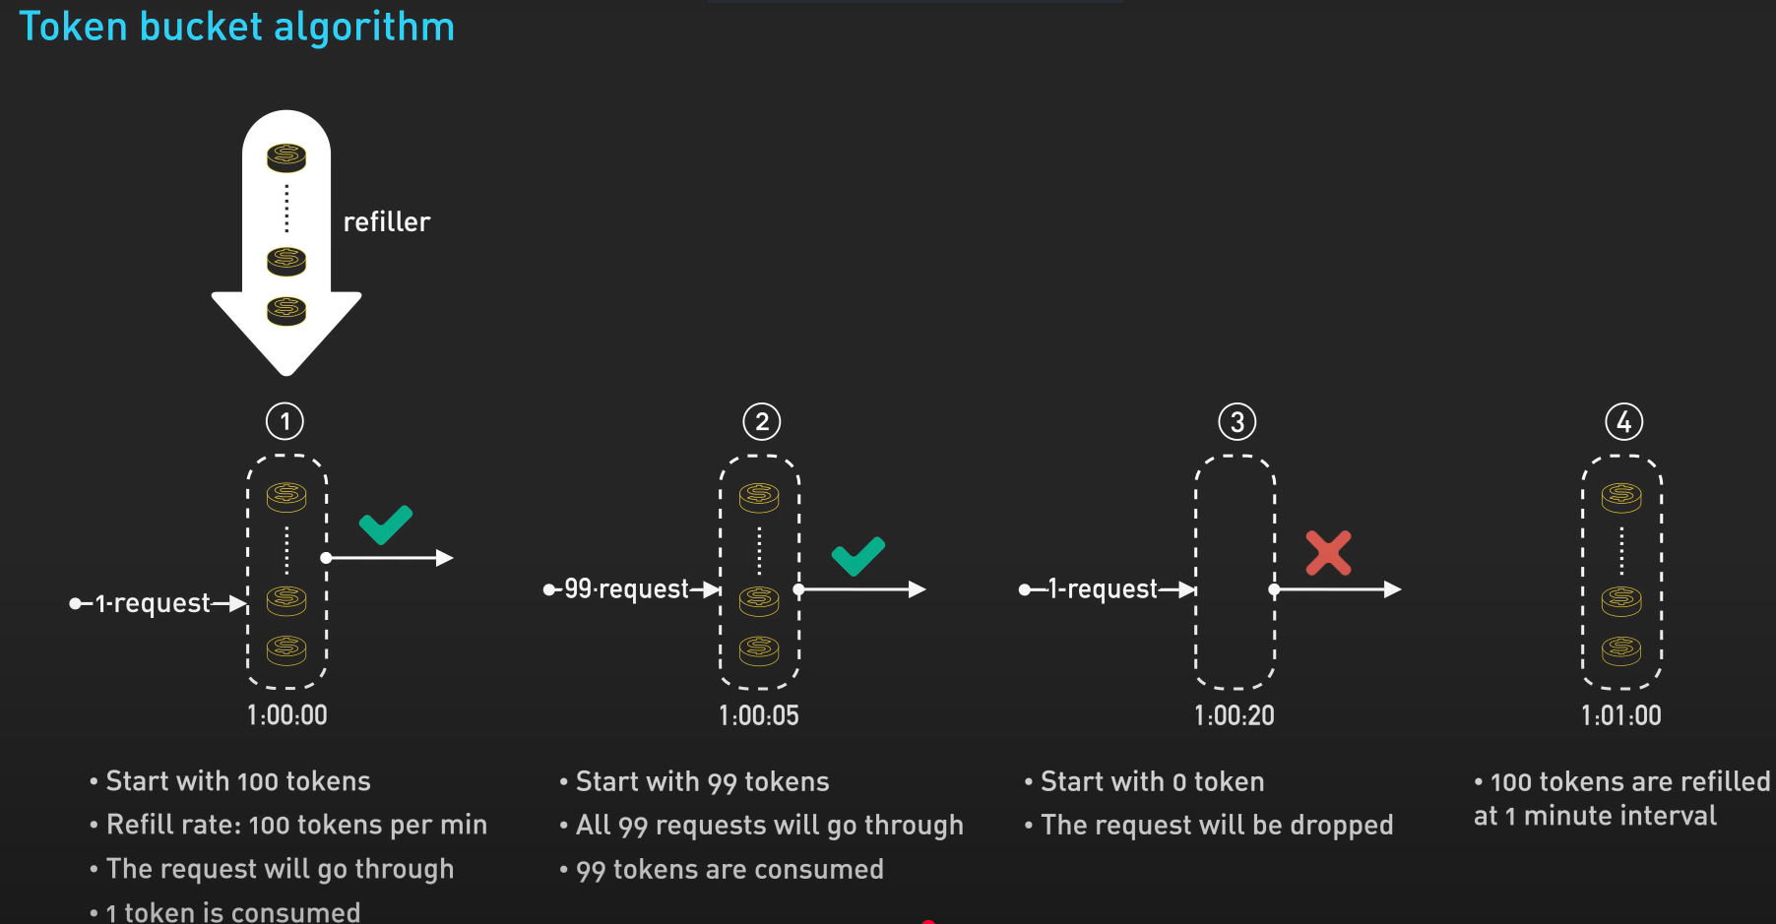

We should put this rate limiter in the middleware in the architecture –

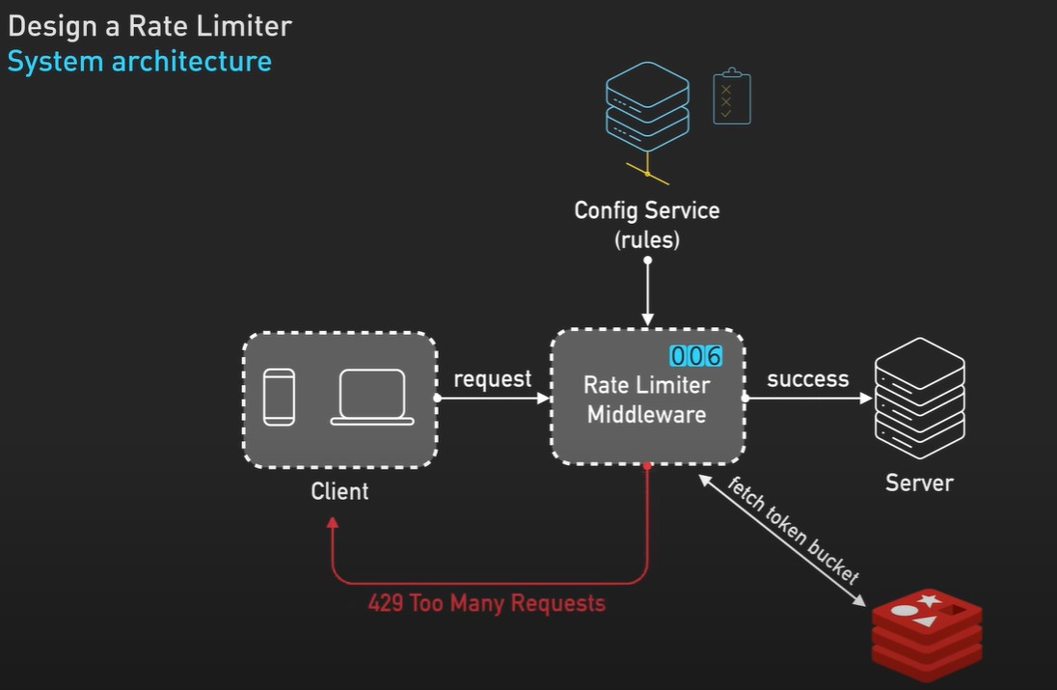

Microservice architecture –

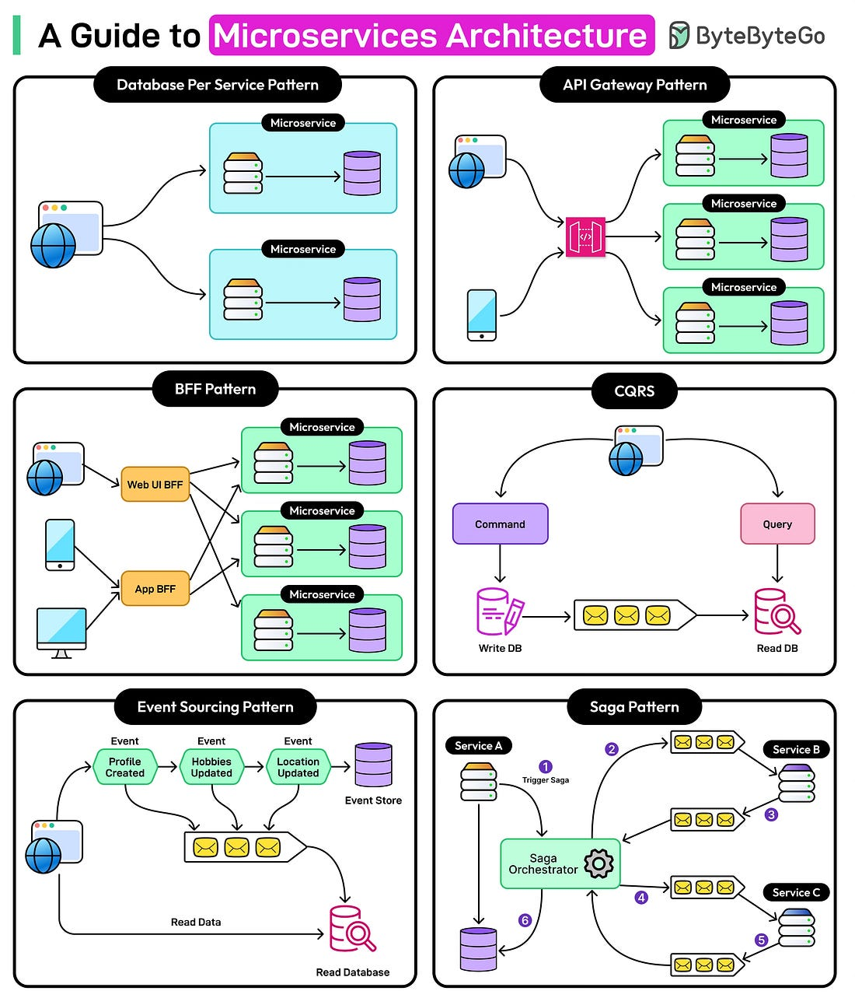

MCP vs. API

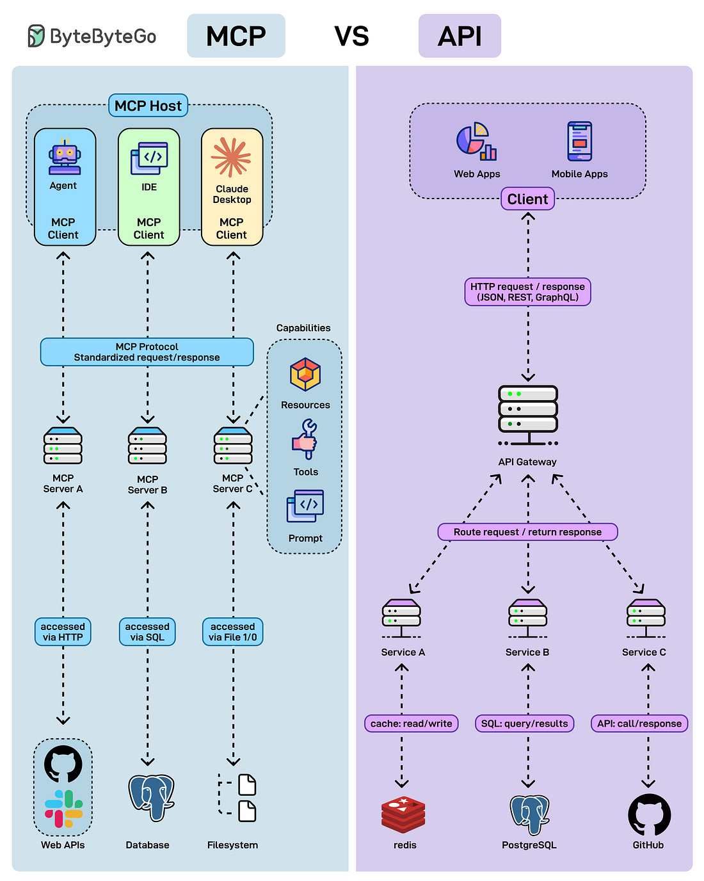

TCP vs. UDP protocols –

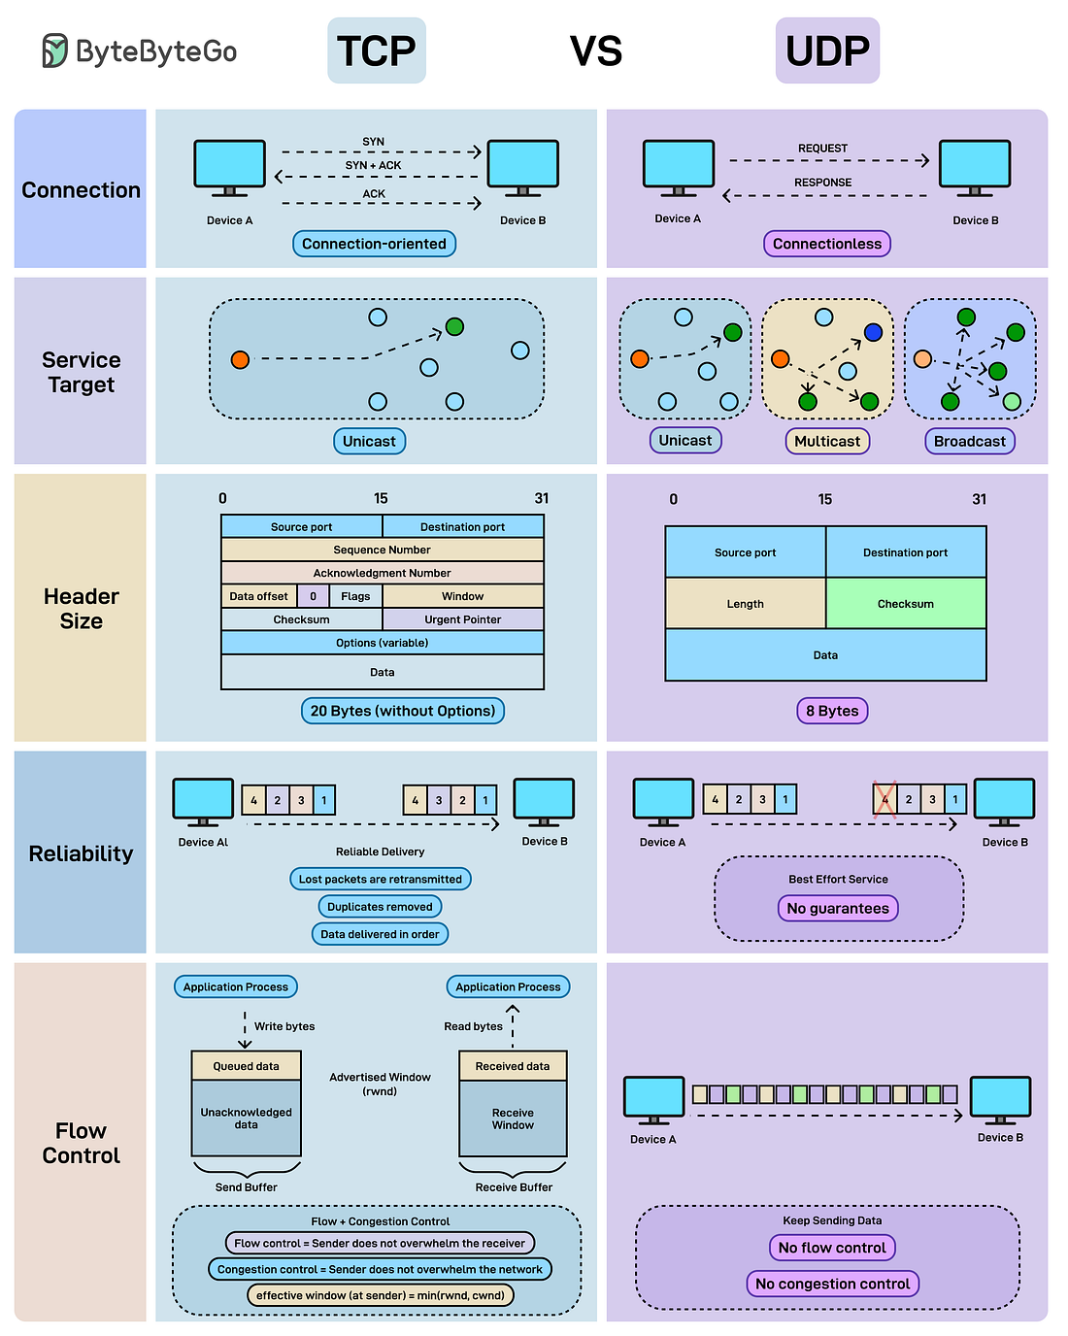

How Python works –

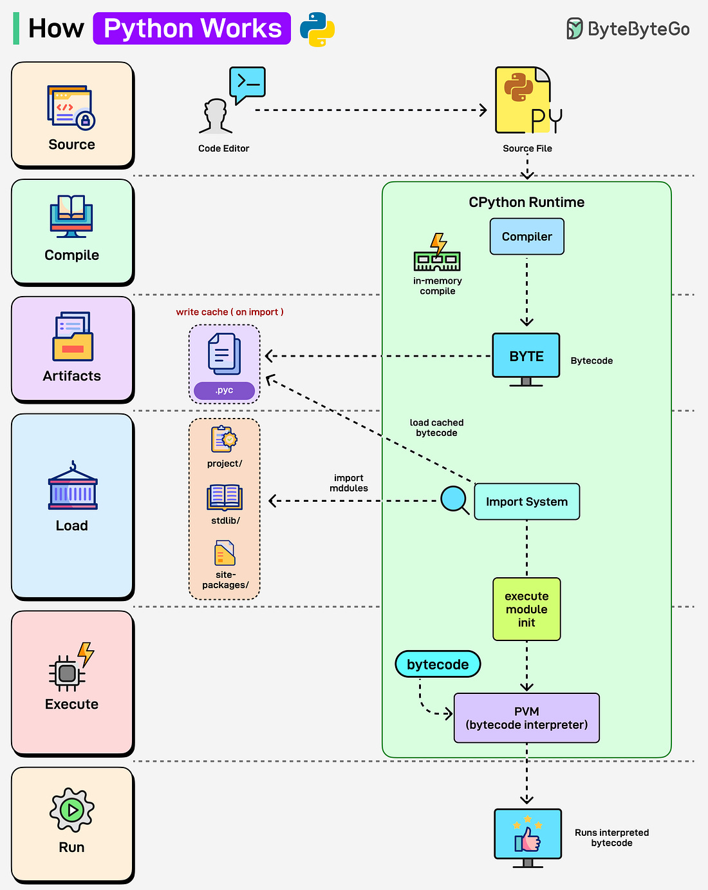

Stateless application –

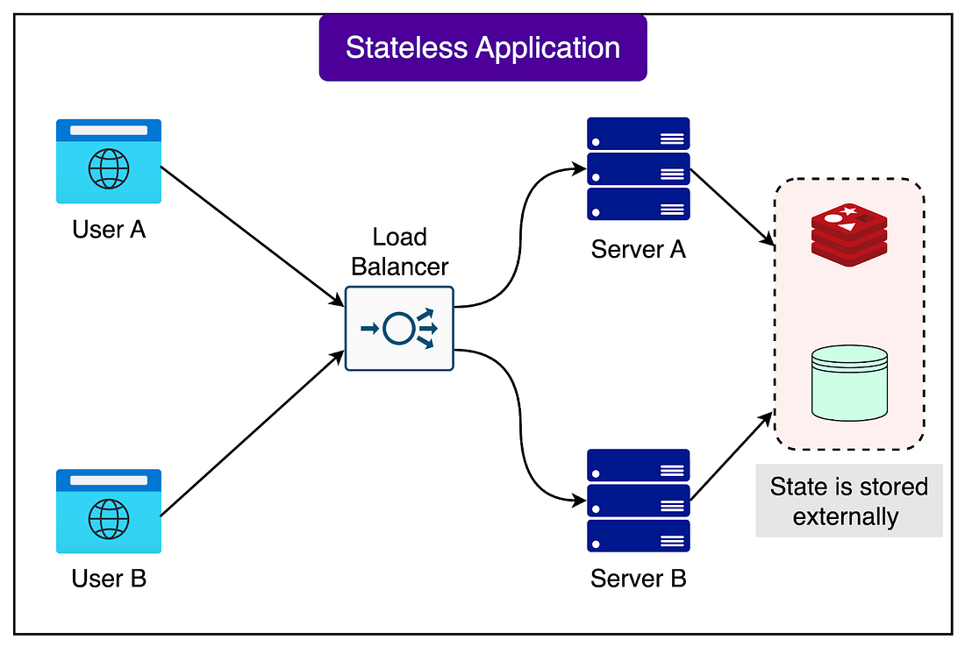

# API vs. SDK

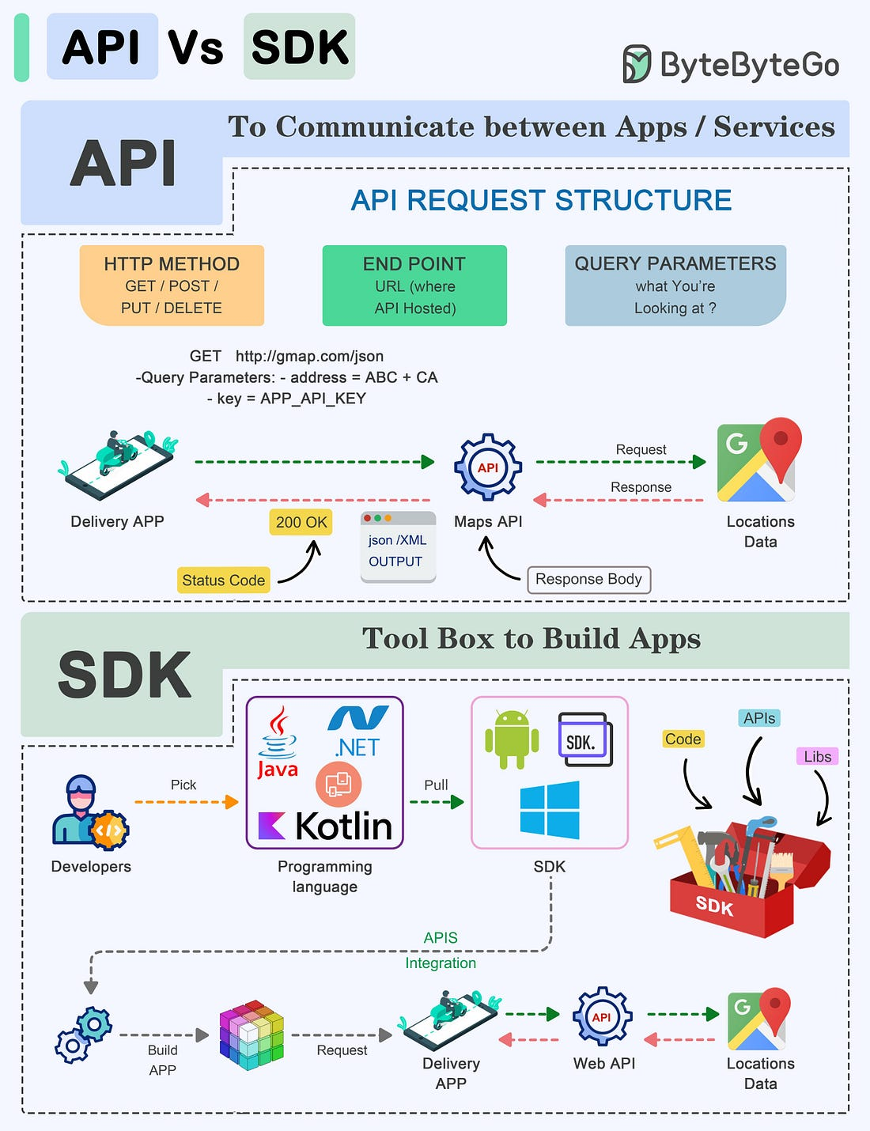

# 24 Best Resources to Learn

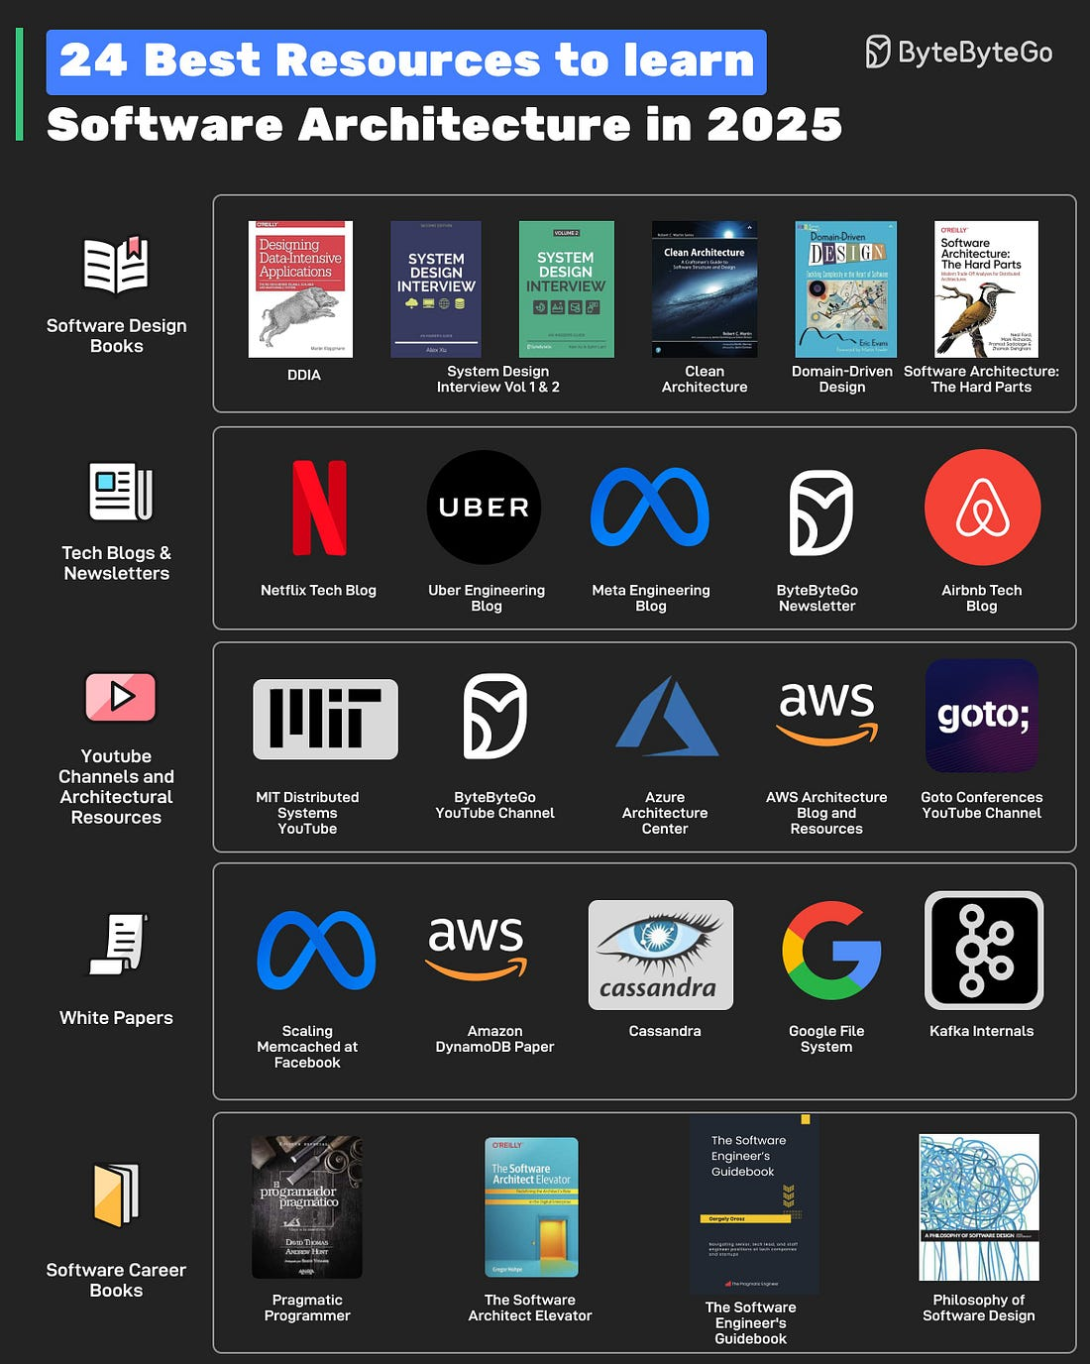

# System Design

<https://hitesh.ai/system-design>

Backend system design –

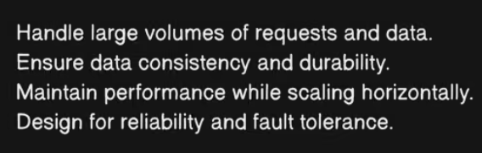

Consider building “ChaiNow”, a global tea-delivery service –

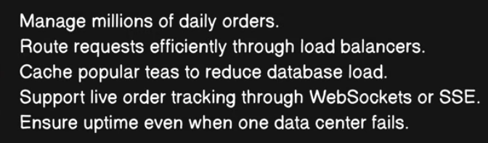

What to study –

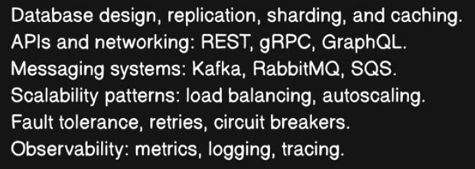

Frontend system design –

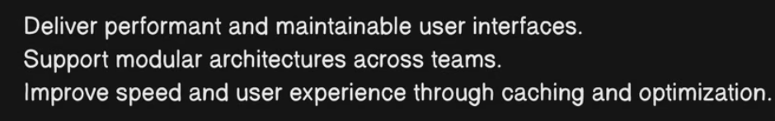

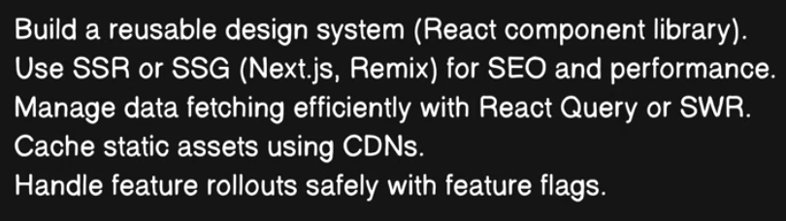

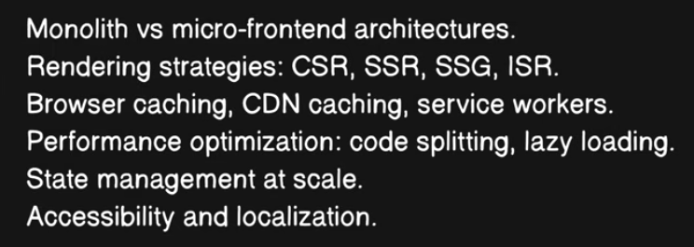

Cloud and infrastructure system design –

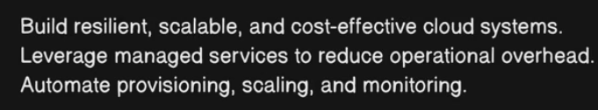

Designing “ChaiCloud”, a multi-region platform –

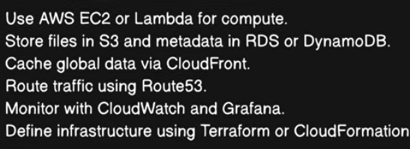

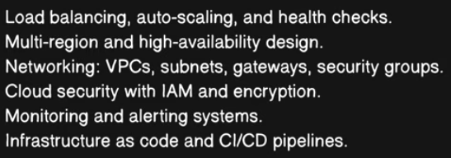

Create a VPC on cloud.

AI and machine learning system design –

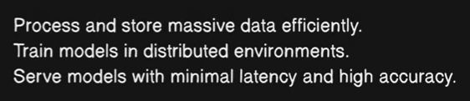

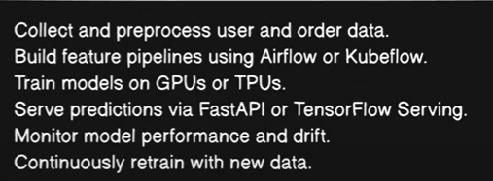

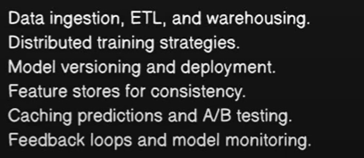

Security and Privacy system design –

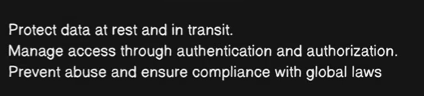

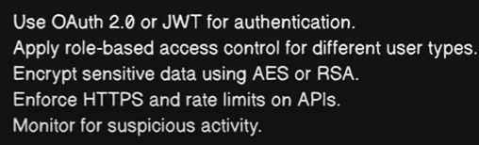

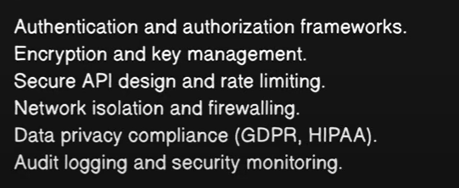

Real-time and streaming system design –

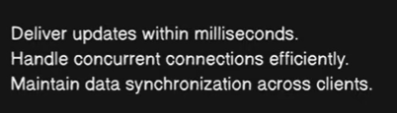

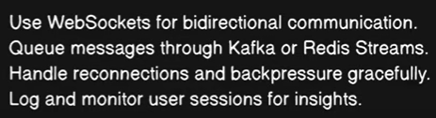

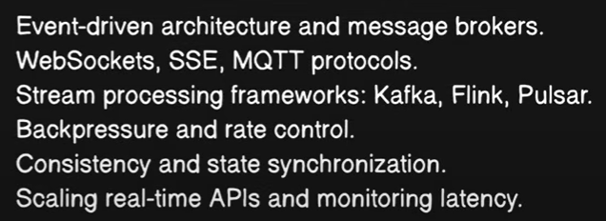

Mobile and Edge system design (like Uber, Duolingo) –

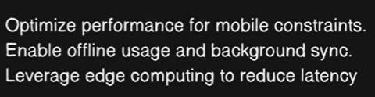

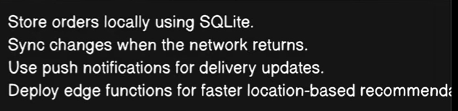

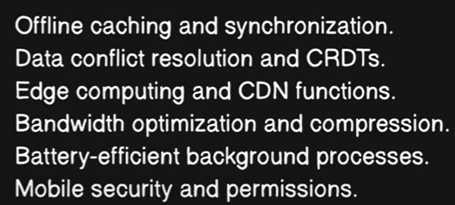

Data Engineering and Analytic System Design –

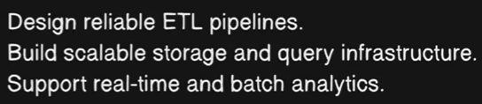

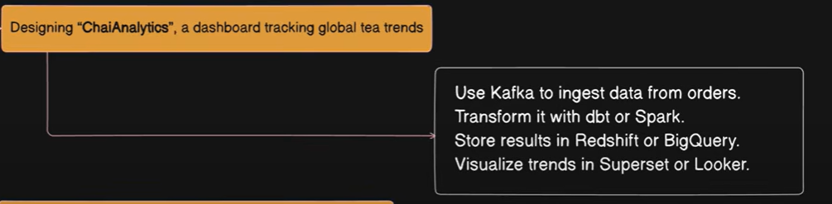

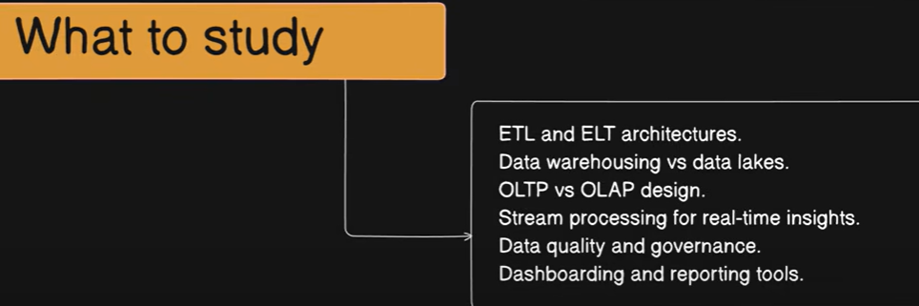

Observability and Reliability system design (SRE) – monitors system heartbeat

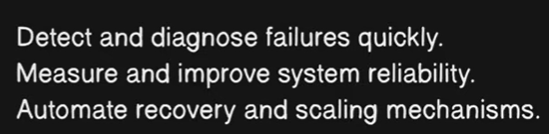

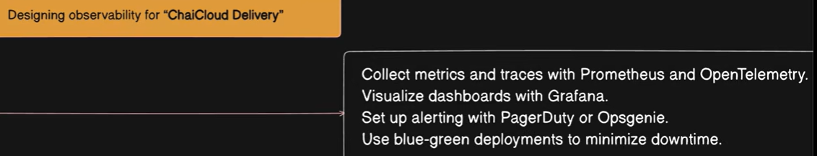

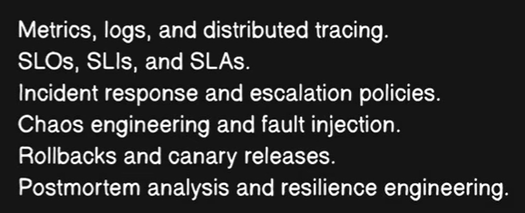

Full-stack system design mindset –

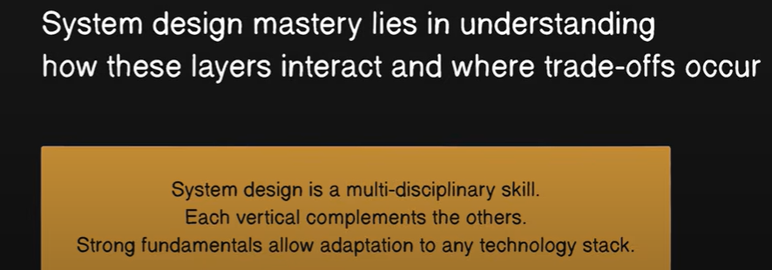

Each vertical complements each other.

# System Design

Latency vs. Throughput –

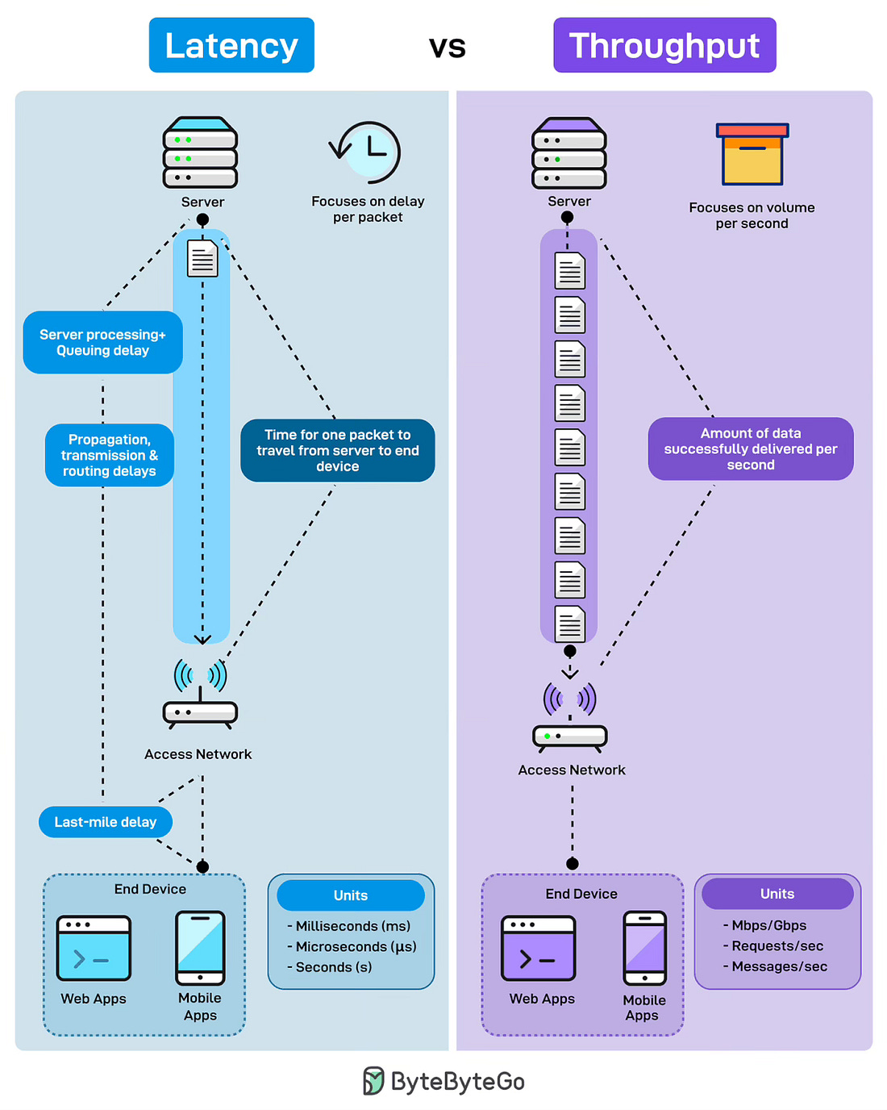

Top 20 System Design concepts –

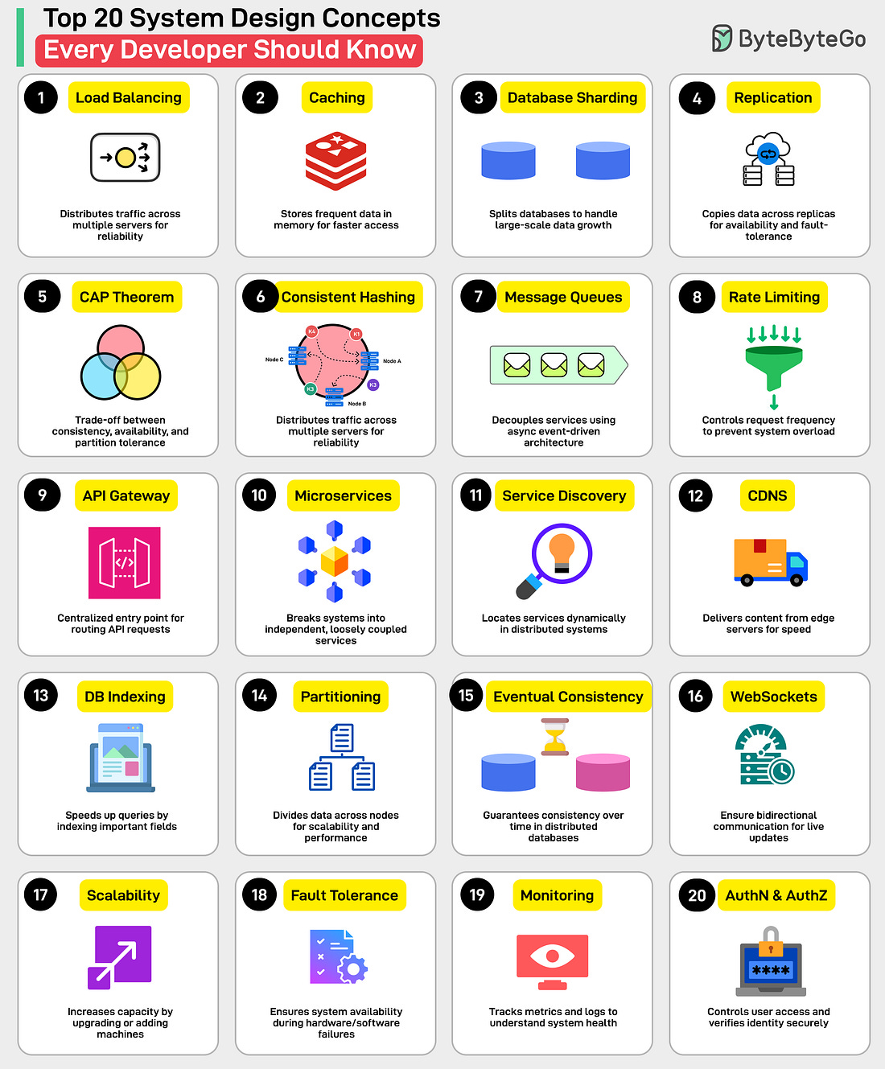

1. Load Balancing: Distributes traffic across multiple servers for reliability and availability.
2. Caching: Stores frequently accessed data in memory for faster access.
3. Database Sharding: Splits databases to handle large-scale data growth.
4. Replication: Copies data across replicas for availability and fault tolerance.
5. CAP Theorem: Trade-off between consistency, availability, and partition tolerance.
6. Consistent Hashing: Distributes load evenly in dynamic server environments.
7. Message Queues: Decouples services using asynchronous event-driven architecture.
8. Rate Limiting: Controls request frequency to prevent system overload.
9. API Gateway: Centralized entry point for routing API requests.
10. Microservices: Breaks systems into independent, loosely coupled services.
11. Service Discovery: Locates services dynamically in distributed systems.
12. CDN: Delivers content from edge servers for speed.
13. Database Indexing: Speeds up queries by indexing important fields.
14. Data Partitioning: Divides data across nodes for scalability and performance.
15. Eventual Consistency: Guarantees consistency over time in distributed databases
16. WebSockets: Enables bi-directional communication for live updates.
17. Scalability: Increases capacity by upgrading or adding machines.
18. Fault Tolerance: Ensures system availability during hardware/software failures.
19. Monitoring: Tracks metrics and logs to understand system health.
20. Authentication & Authorization: Controls user access and verifies identity securely.

How to debug a slow API –

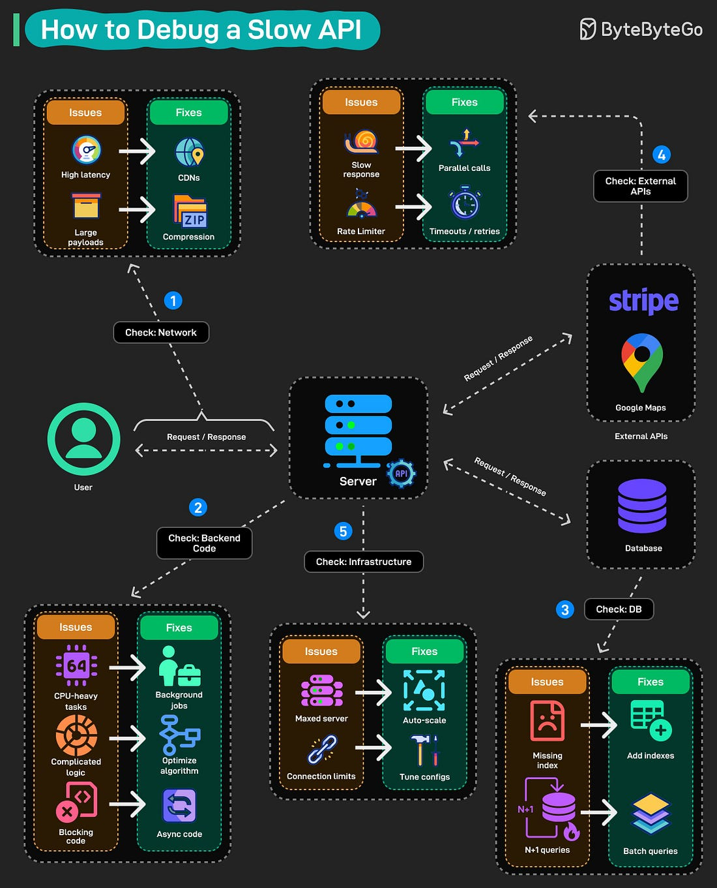

How LLM sees the world –

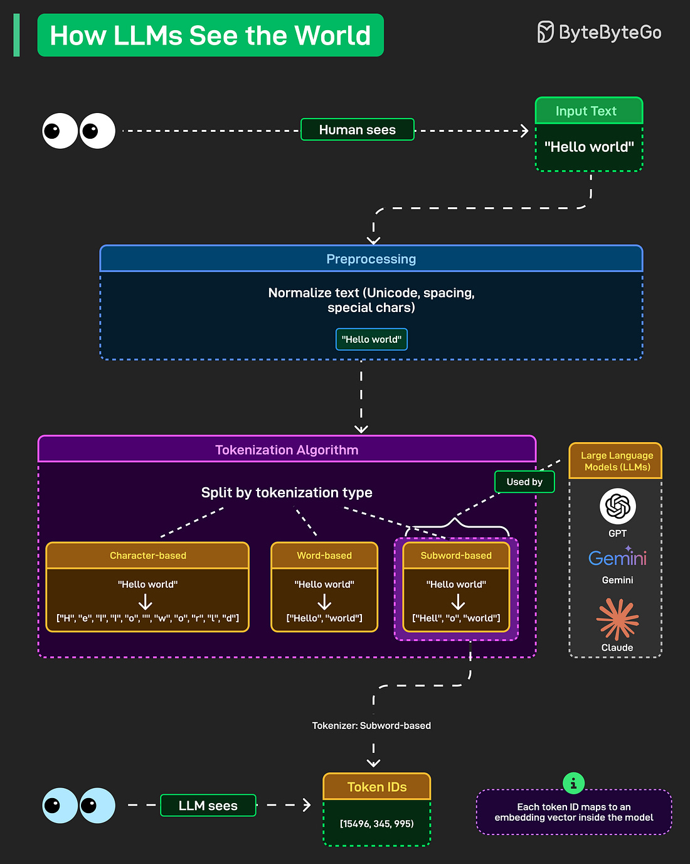

RAG vs. Fine-tuning –

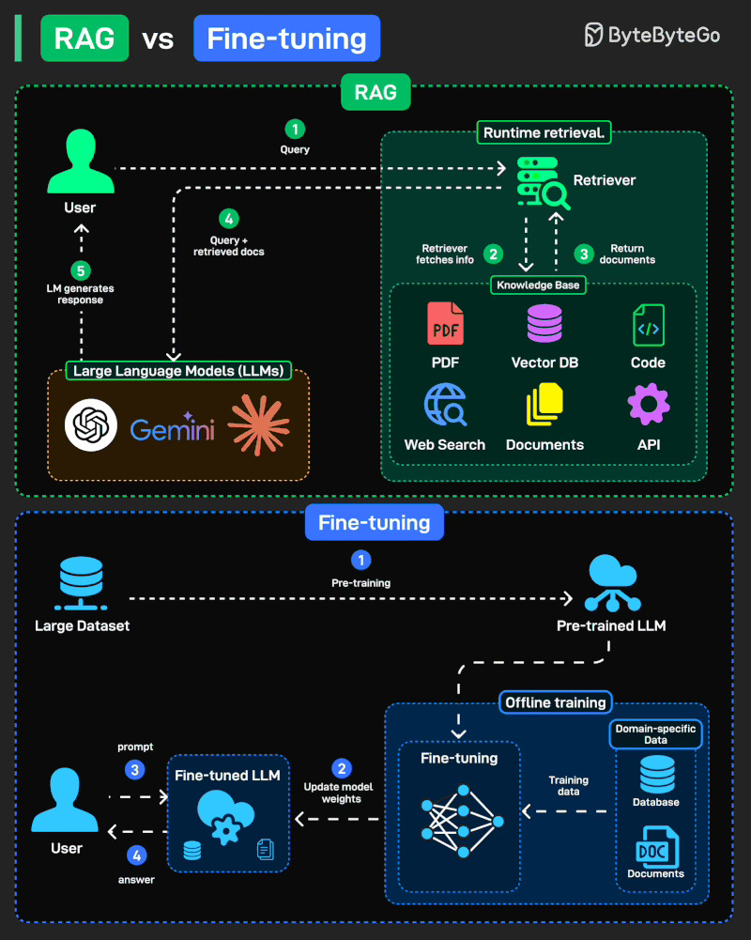

API Gateway –

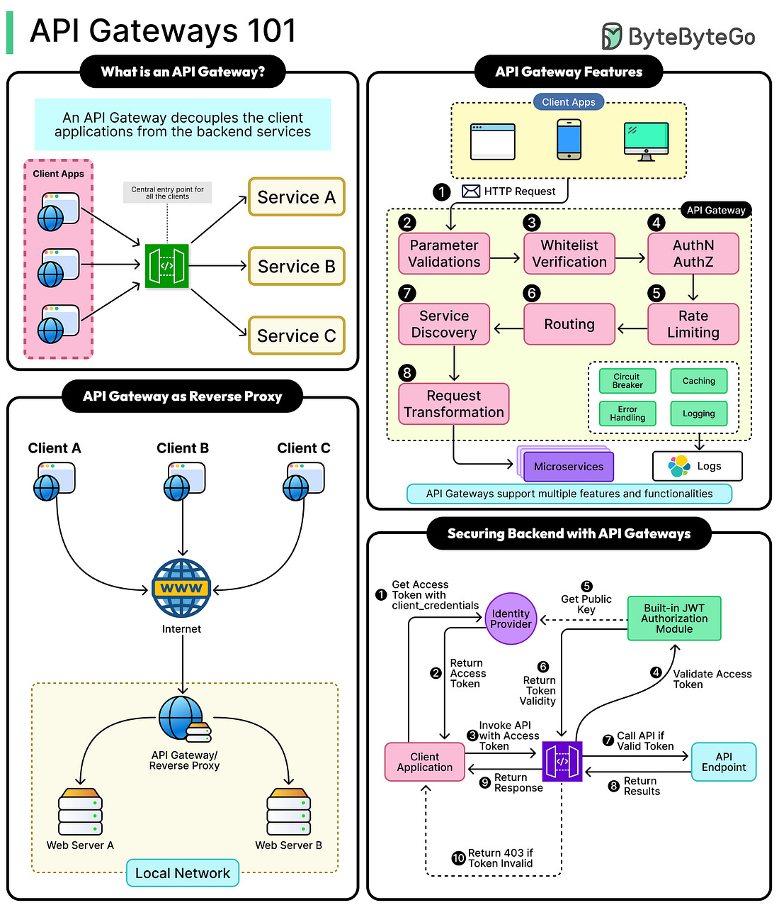

How RAG works –

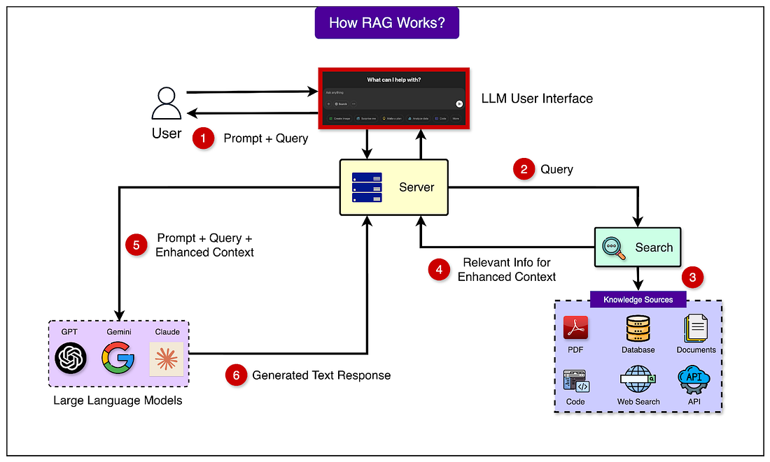

Docker vs. Kubernetes –

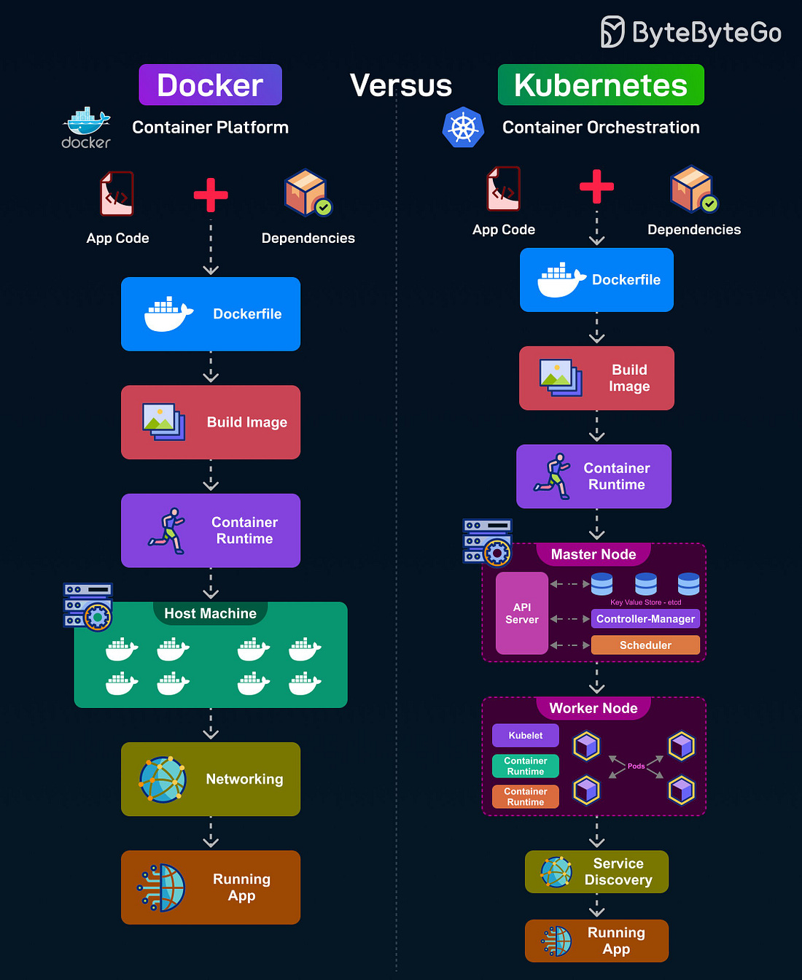

Batch vs. stream processing –

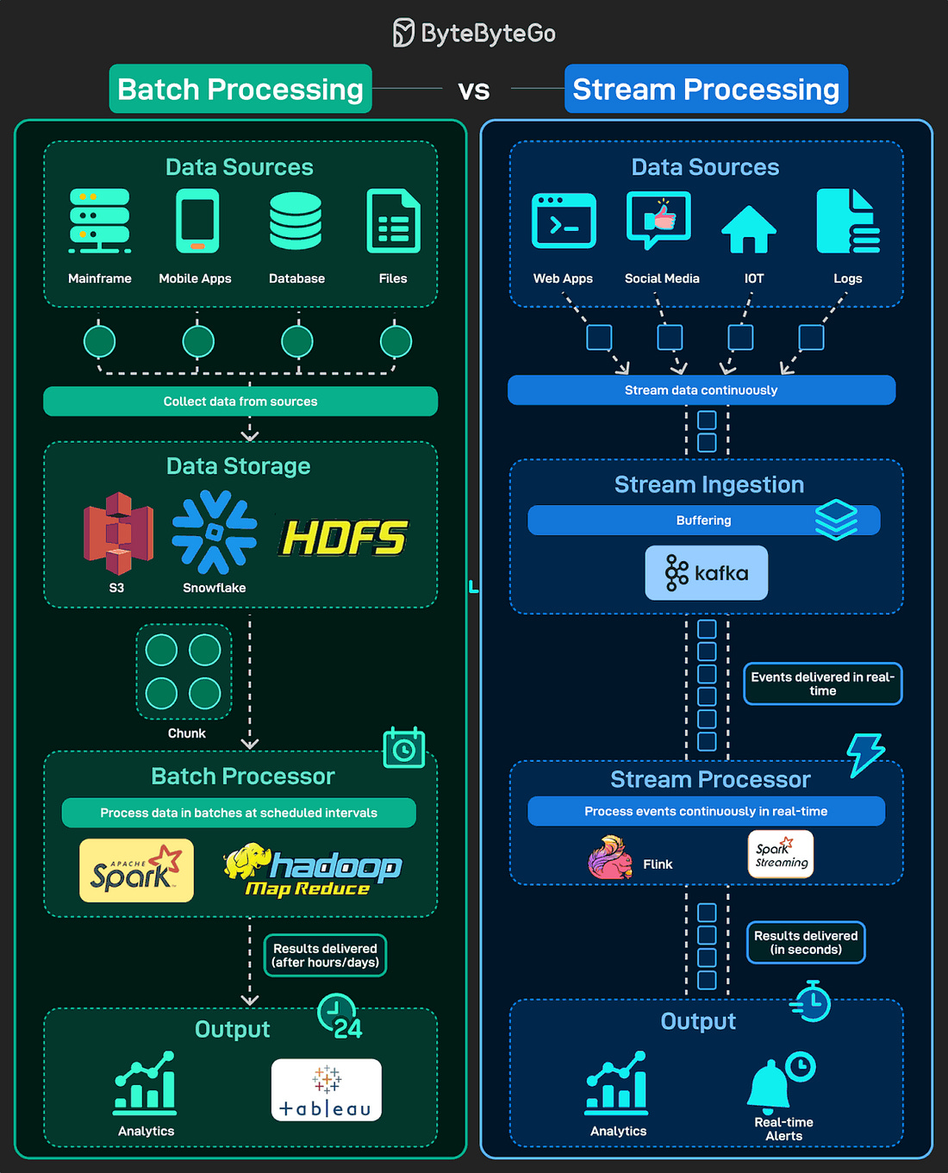

Modular monoliths –

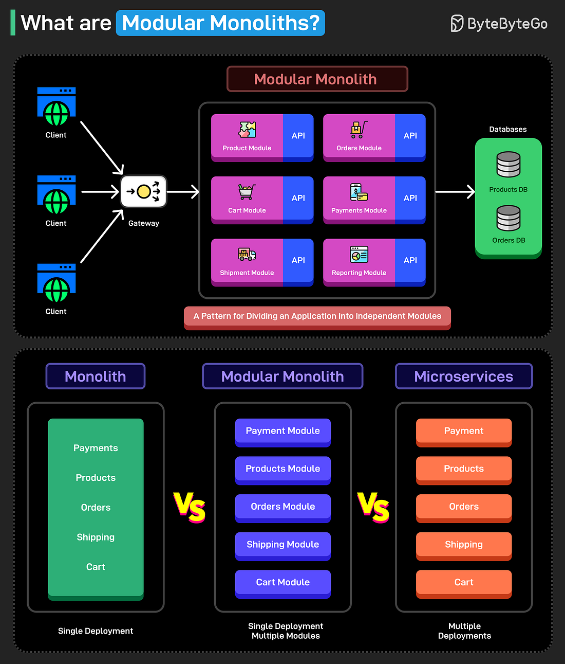

Program vs. process vs. thread –

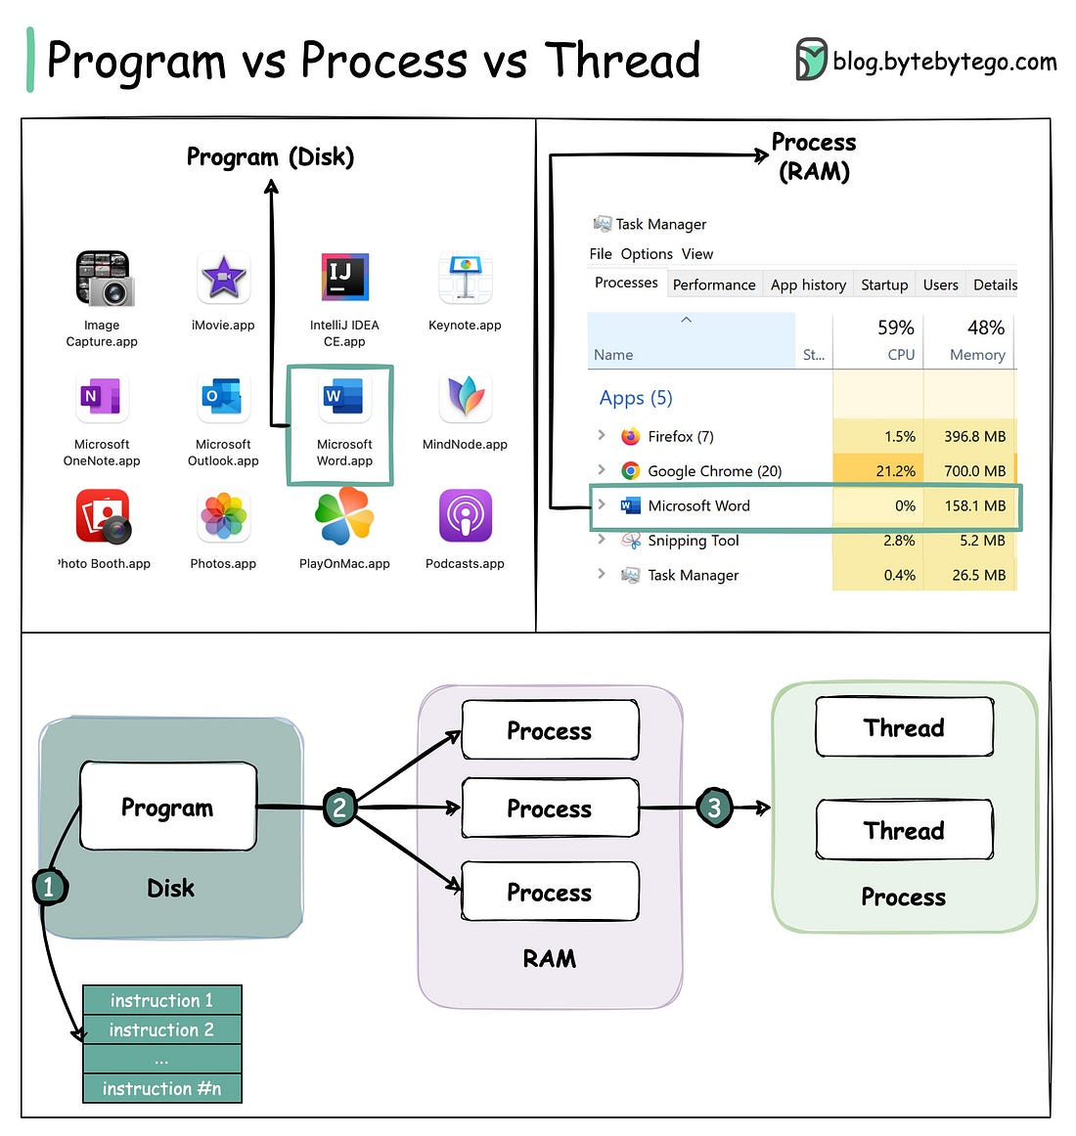

SQL Cheat sheet –

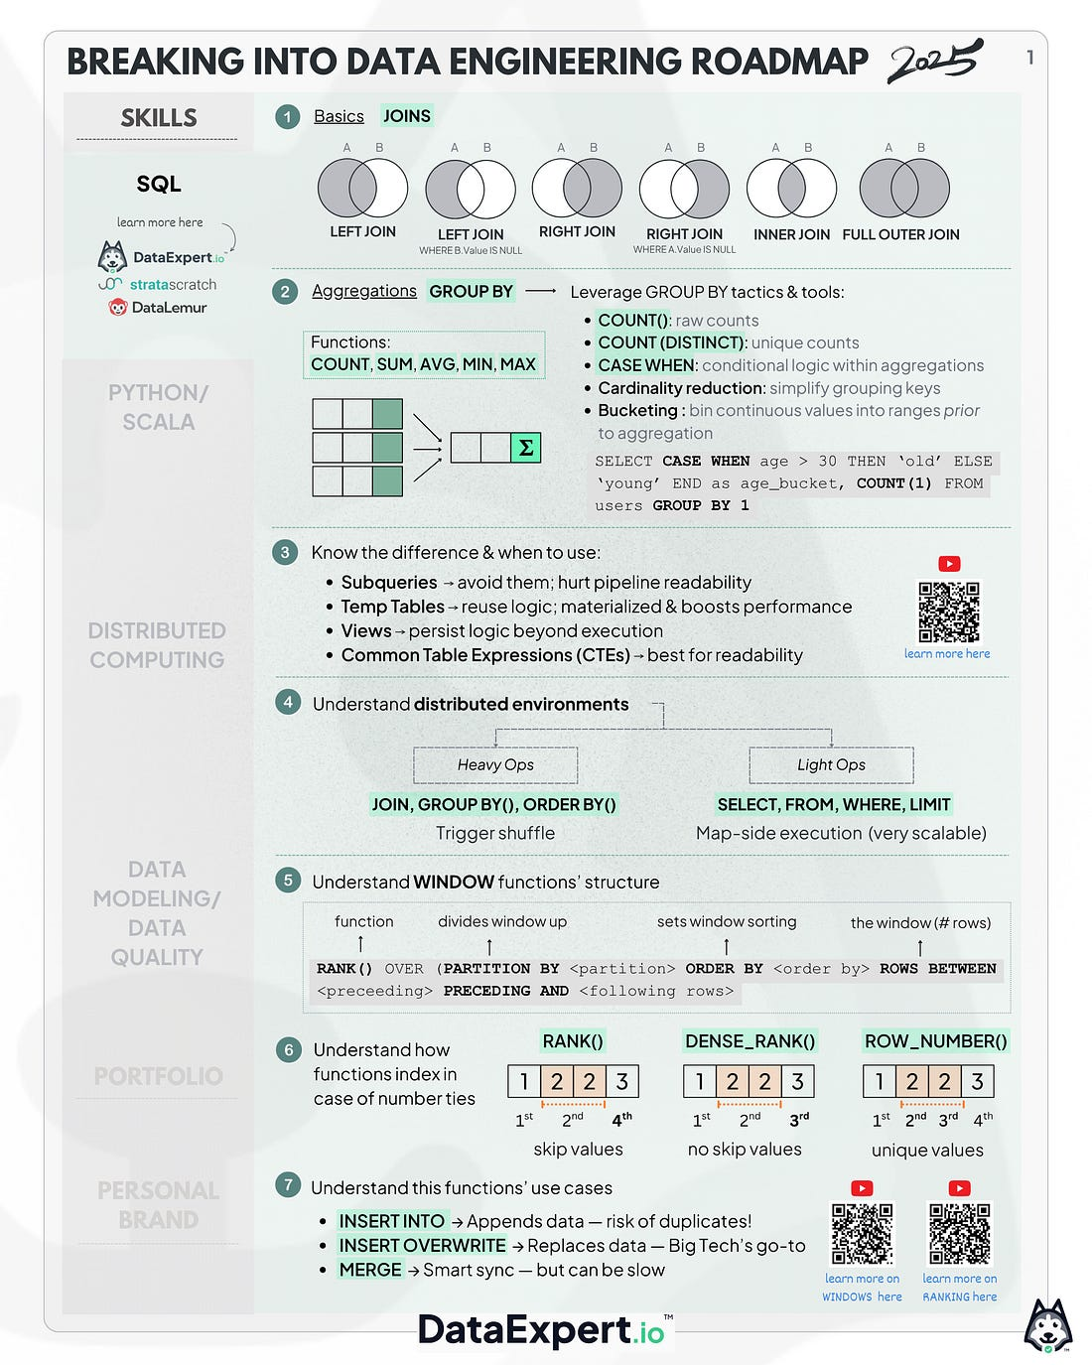

# System Design

API Gateways



Service-to-service communication pattern –

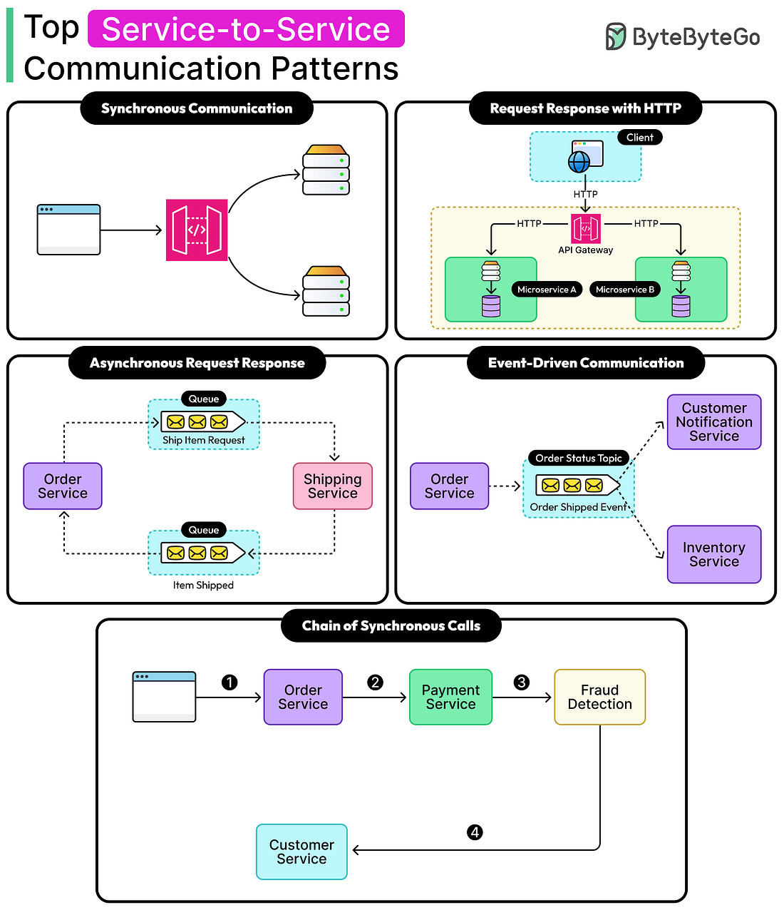

Top 20 system design concepts –

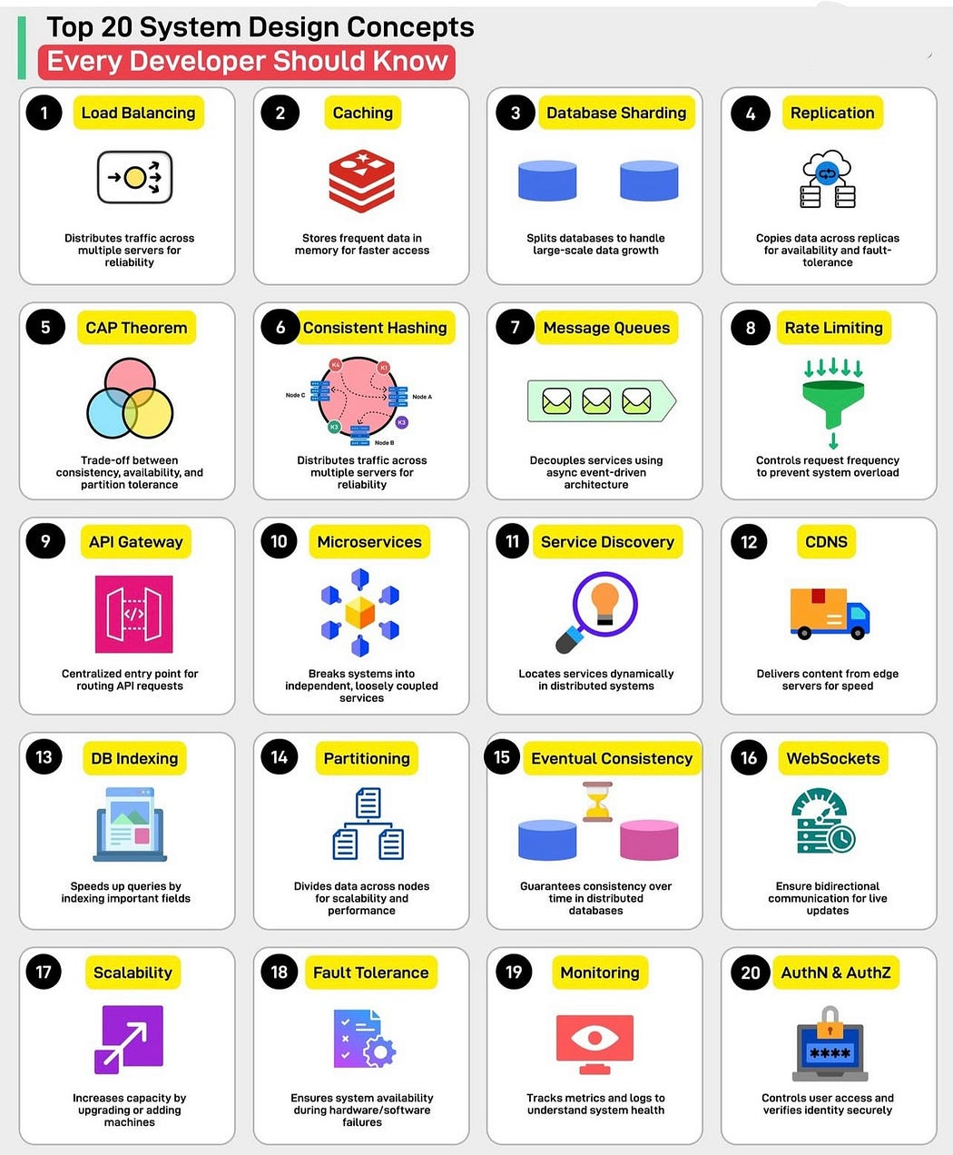

**1. Load Balancing**

**What:** Distributes traffic across multiple servers.

**Why:** To prevent any single server from being overwhelmed.

**Example (Node.js):**  
You can place a **load balancer (e.g., Nginx or AWS ELB)** in front of your Node.js app servers to distribute traffic:

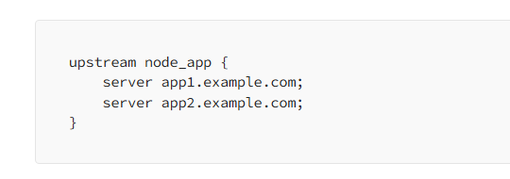

**2. Caching**

**What:** Temporarily stores frequently accessed data.

**Why:** Speeds up response time and reduces database load.

**Example (Node.js + Redis):**

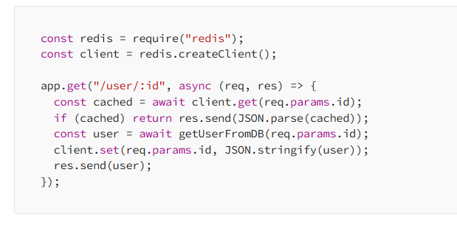

**3. Database Sharding**

**What:** Splits a large database into smaller chunks (shards).

**Why:** Improves performance and manageability for large data sets.

**Node Tip:** You might route DB queries to different MongoDB shards using Mongoose and shard keys.

**4. Replication**

**What:** Copies data from one DB server to others.

**Why:** Ensures high availability and fault tolerance.

**Node Use Case:** With MongoDB replica sets, your Node app automatically reads from secondary if primary fails.

**5. CAP Theorem**

**What:** You can only have two out of **Consistency**, **Availability**, and **Partition Tolerance**.

**Why:** It helps you understand the trade-offs in distributed systems.

**Real Talk:** In Node apps using MongoDB (eventually consistent), you trade strong consistency for availability.

**6. Consistent Hashing**

**What:** Smart way to distribute data across servers evenly.

**Why:** Prevents large data movement when adding/removing servers.

**Example:** Used in distributed caches like Redis Cluster, and CDN edge servers.

**7. Message Queues**

**What:** Queues used to send tasks between services asynchronously.

**Why:** Helps in decoupling services and handling spikes in traffic.

**Example (Node.js + RabbitMQ):**

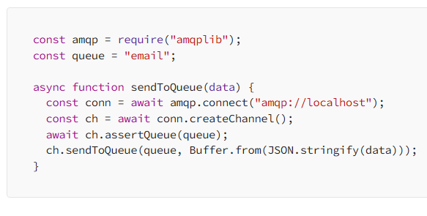

**8. Rate Limiting**

**What:** Controls how many requests a user can make.

**Why:** Protects your app from abuse or DDoS.

**Example (Node.js + express-rate-limit):**

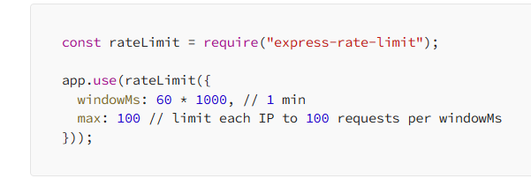

**9. API Gateway**

**What:** Central entry point for all client requests.

**Why:** Routes, authenticates, and manages traffic.

**Example:** Use **Express Gateway** or **Kong** in front of your microservices.

**10. Microservices**

**What:** Breaks an app into small, independent services.

**Why:** Easier to scale and maintain.

**Node.js Tip:** Use different Node services for user, order, and payment logic, each deployed separately.

**11. Service Discovery**

**What:** Auto-finds service addresses in dynamic environments.

**Why:** Helps services communicate without hardcoding addresses.

**Node Example:** Use **Consul** or **Eureka** with service names instead of IPs.

**12. CDNs (Content Delivery Networks)**

**What:** Delivers static files from edge servers near the user.

**Why:** Reduces latency and improves performance.

**Node Use:** Serve React static files via **Cloudflare** or **Amazon CloudFront**.

**13. Database Indexing**

**What:** Creates shortcuts in DB to speed up queries.

**Why:** Reduces query time for large data.

**Node + MongoDB:**

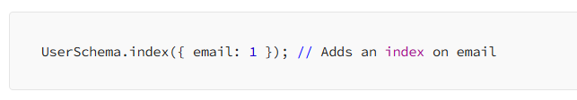

**14. Partitioning**

**What:** Divides data into parts across databases/nodes.

**Why:** Helps with performance and scaling.

**Example:** Split users by country into different DB instances.

**15. Eventual Consistency**

**What:** Guarantees that all nodes will eventually sync data.

**Why:** Needed in distributed systems for availability.

**Node Example:** Services might sync their local cache with a DB asynchronously.

**16. WebSockets**

**What:** Allows real-time two-way communication.

**Why:** Useful for chat, notifications, games.

**Node.js Example:**

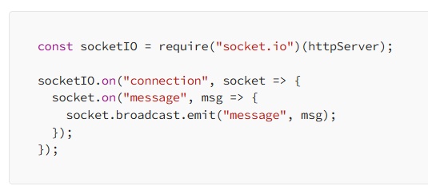

**17. Scalability**

**What:** System’s ability to grow with traffic.

**Why:** Makes sure your app can handle more users.

**Node Tips:** Use horizontal scaling (more servers), stateless services, and auto-scaling groups.

**18. Fault Tolerance**

**What:** System continues working even if parts fail.

**Why:** Prevents total outages.

**Node Practice:** Retry failed tasks, use circuit breakers (like with opossum package), and health checks.

**19. Monitoring**

**What:** Collects metrics and logs.

**Why:** Helps track system health and debug issues.

**Node Tools:** Use **Prometheus**, **Grafana**, or **New Relic** with custom metrics and alerts.

**20. AuthN & AuthZ**

**What:** AuthN = Authentication (who are you?), AuthZ = Authorization (what can you do?).

**Why:** Secures your app.

**Node Example (JWT):**

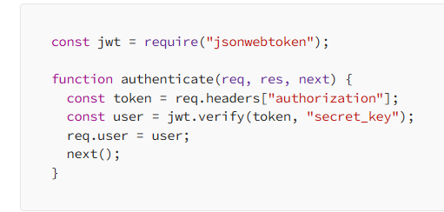

# System Design

10 data structures used in daily life –

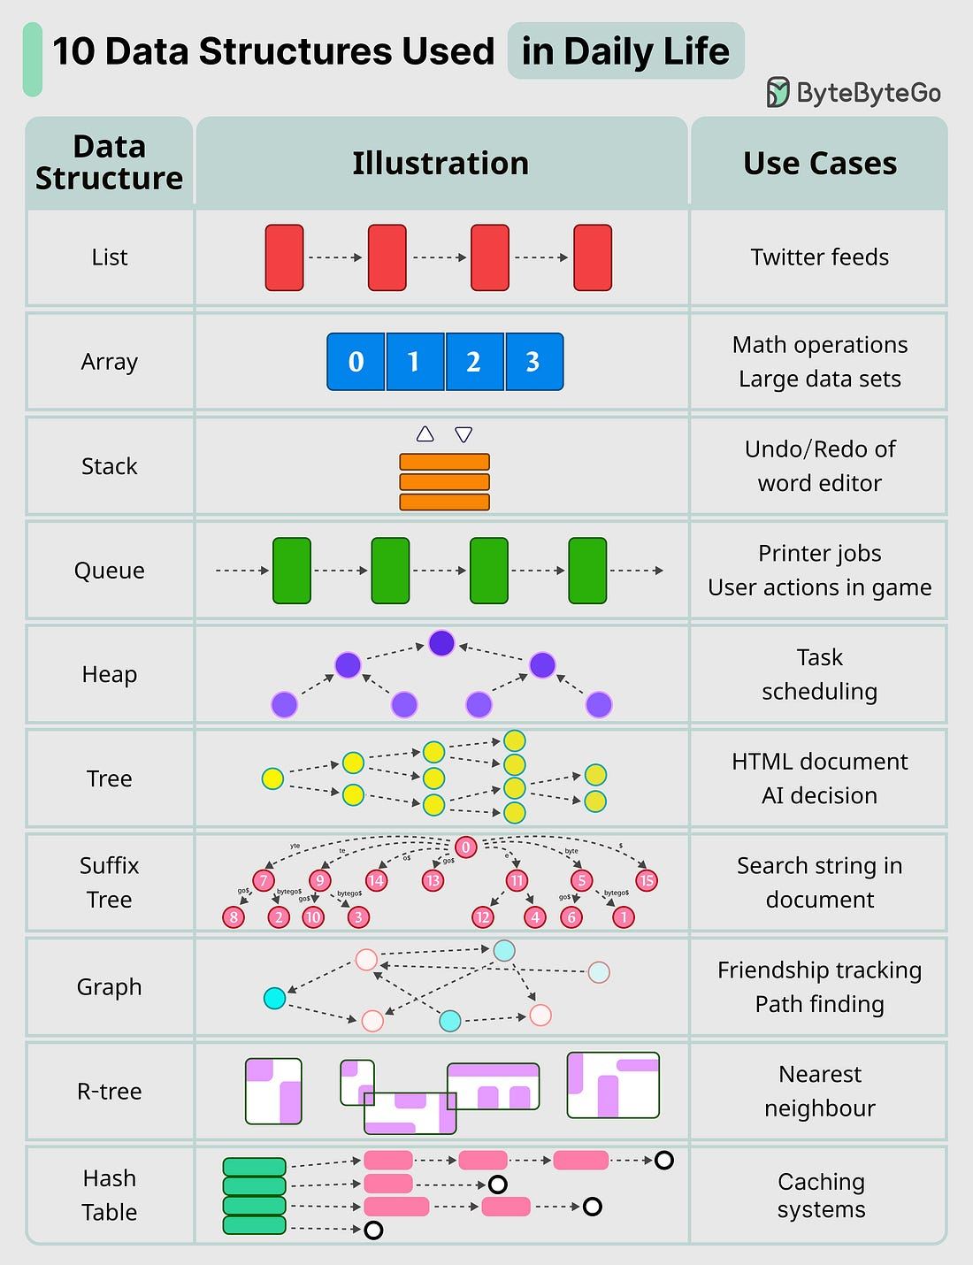

IP Address cheat sheet –

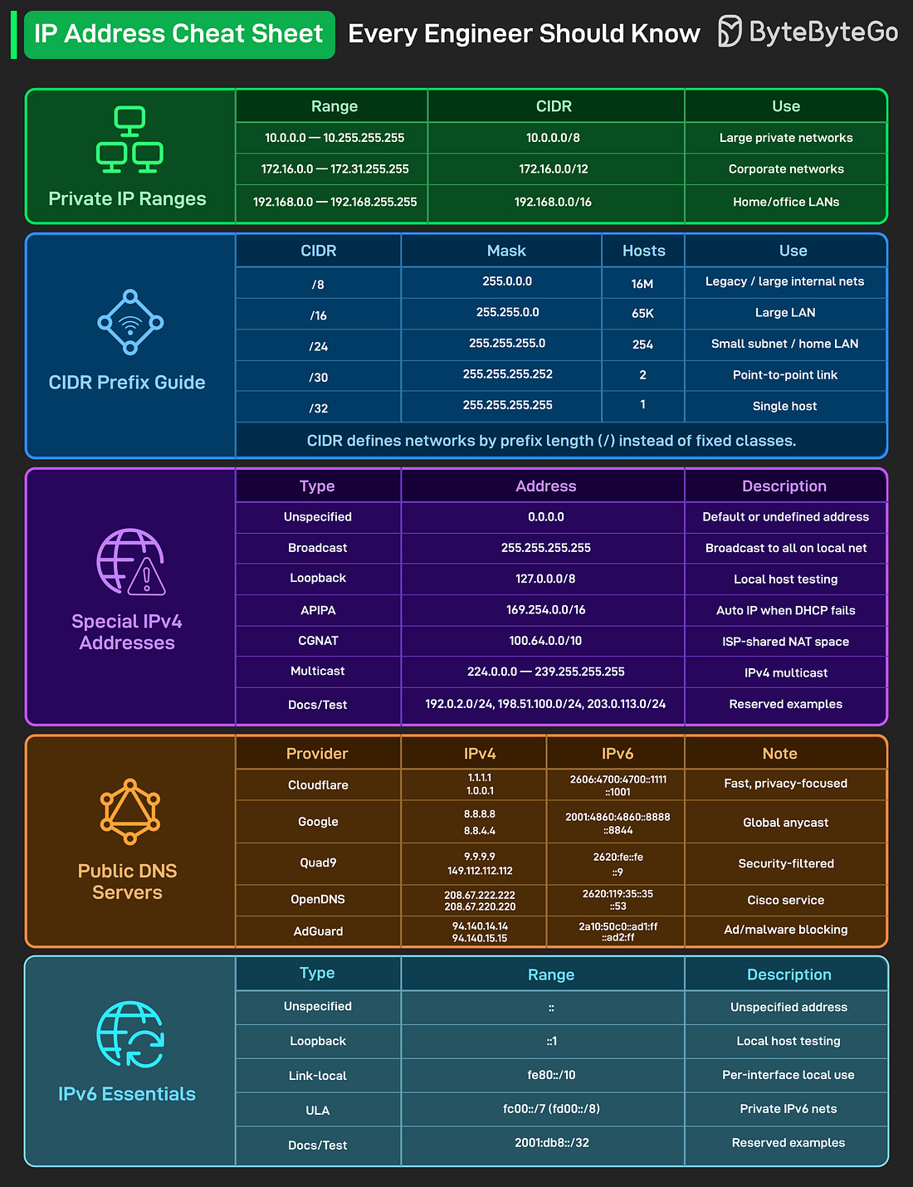

TCP and UDP protocols –

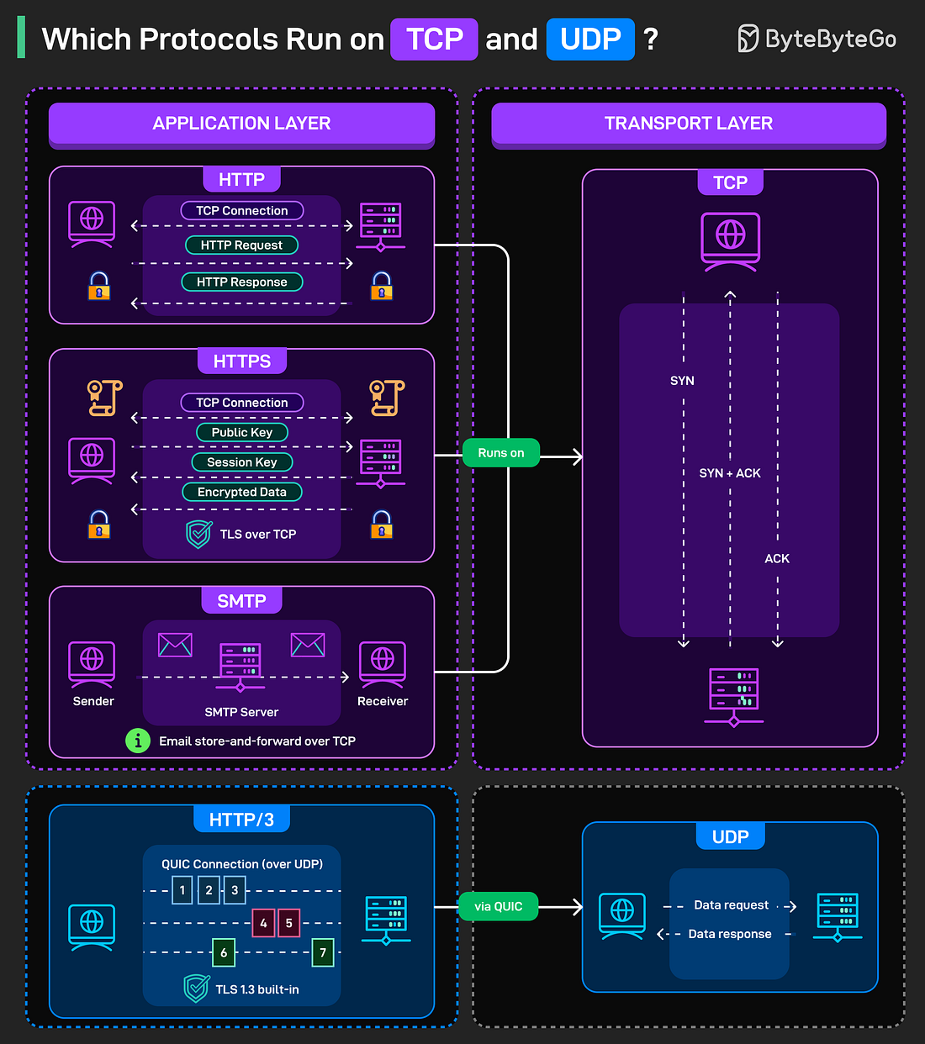

## System Design

Java vs. Python

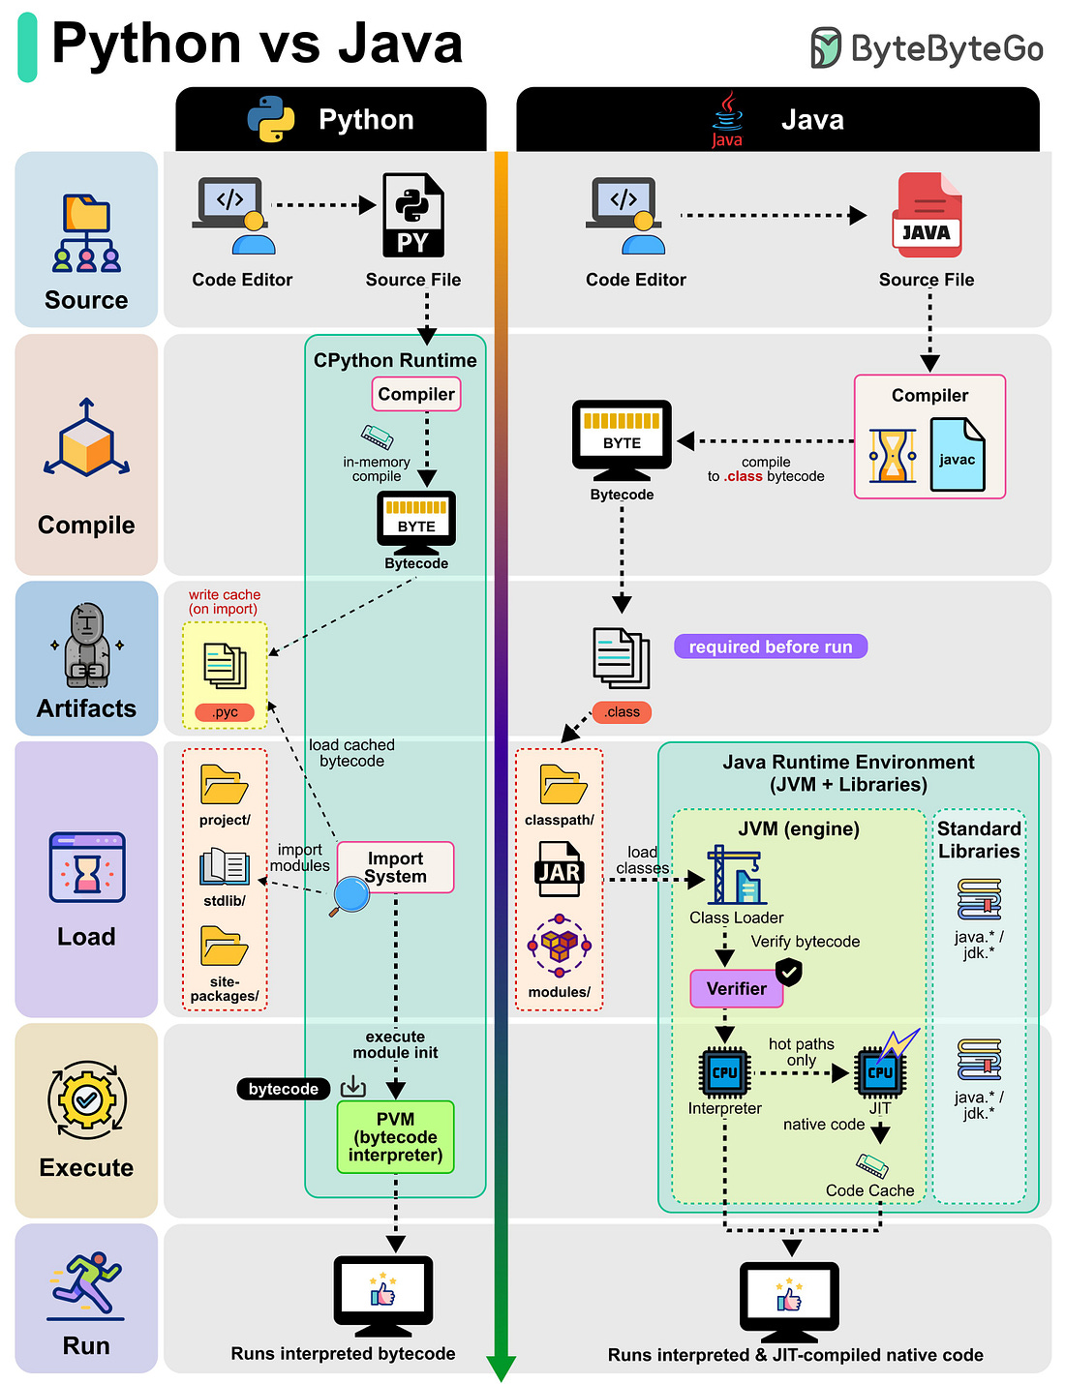

CI/CD Workflow –

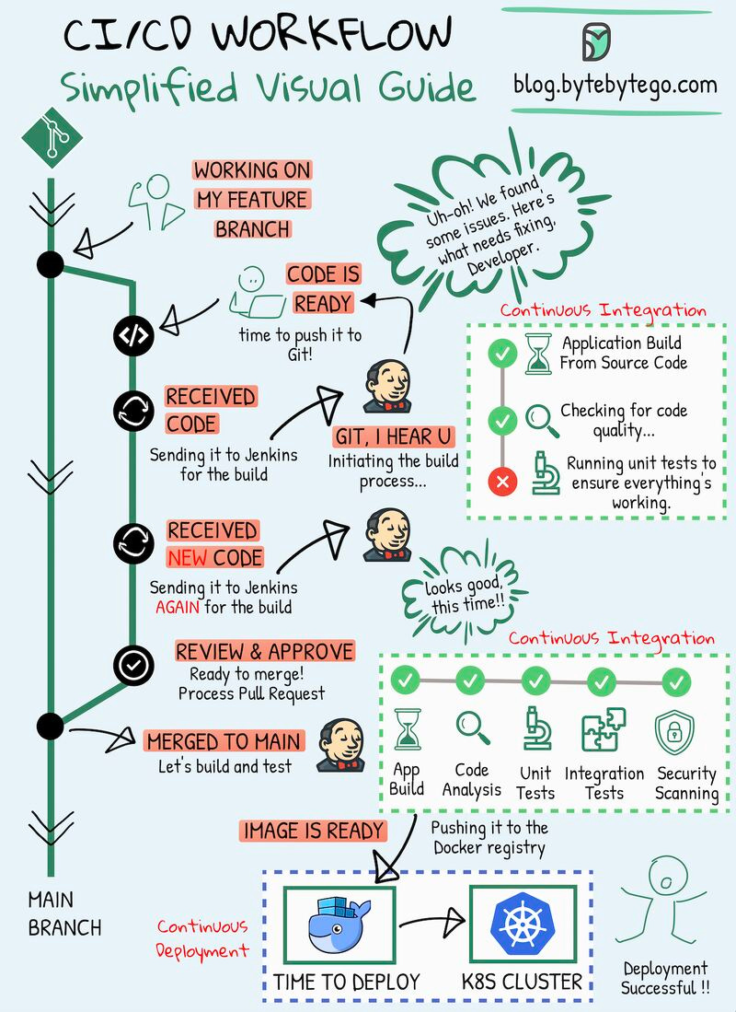

Load Balancers vs. API Gateway vs. Reverse Proxy –

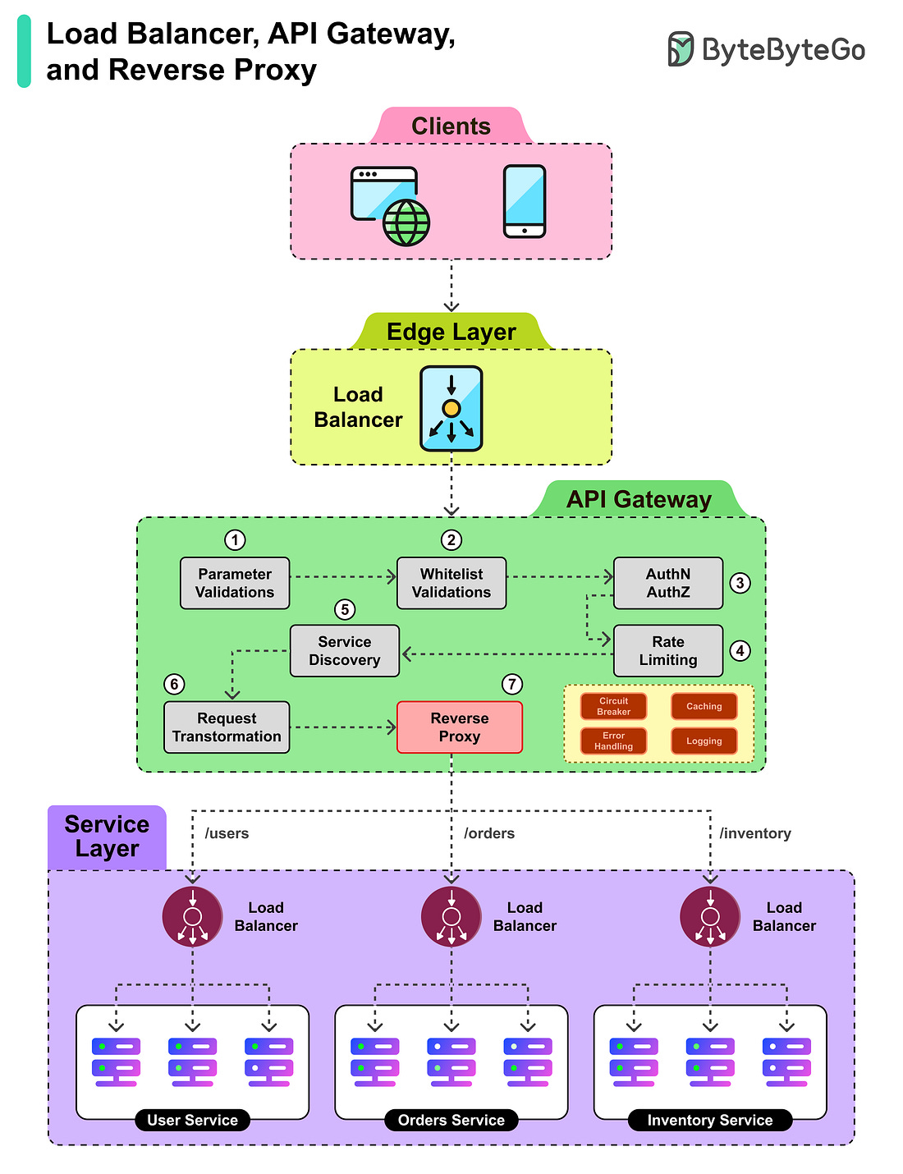

The Modern Software Stack

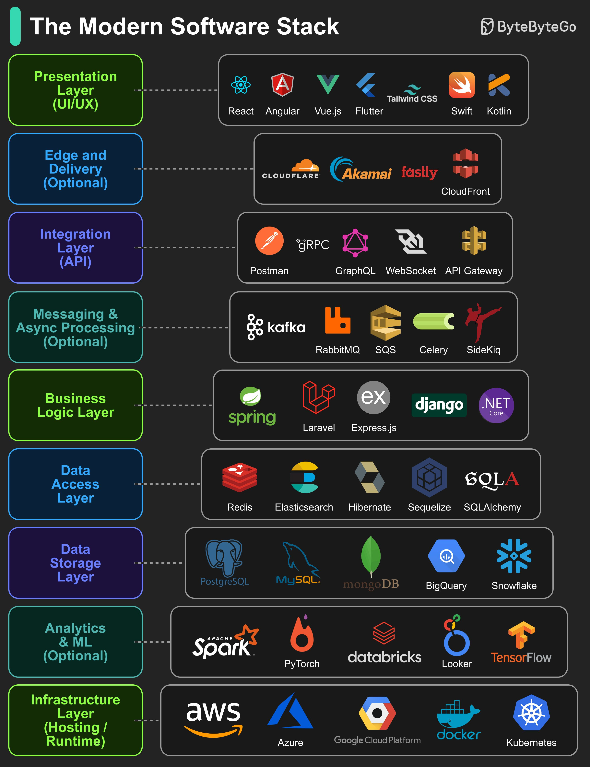

How Java works –

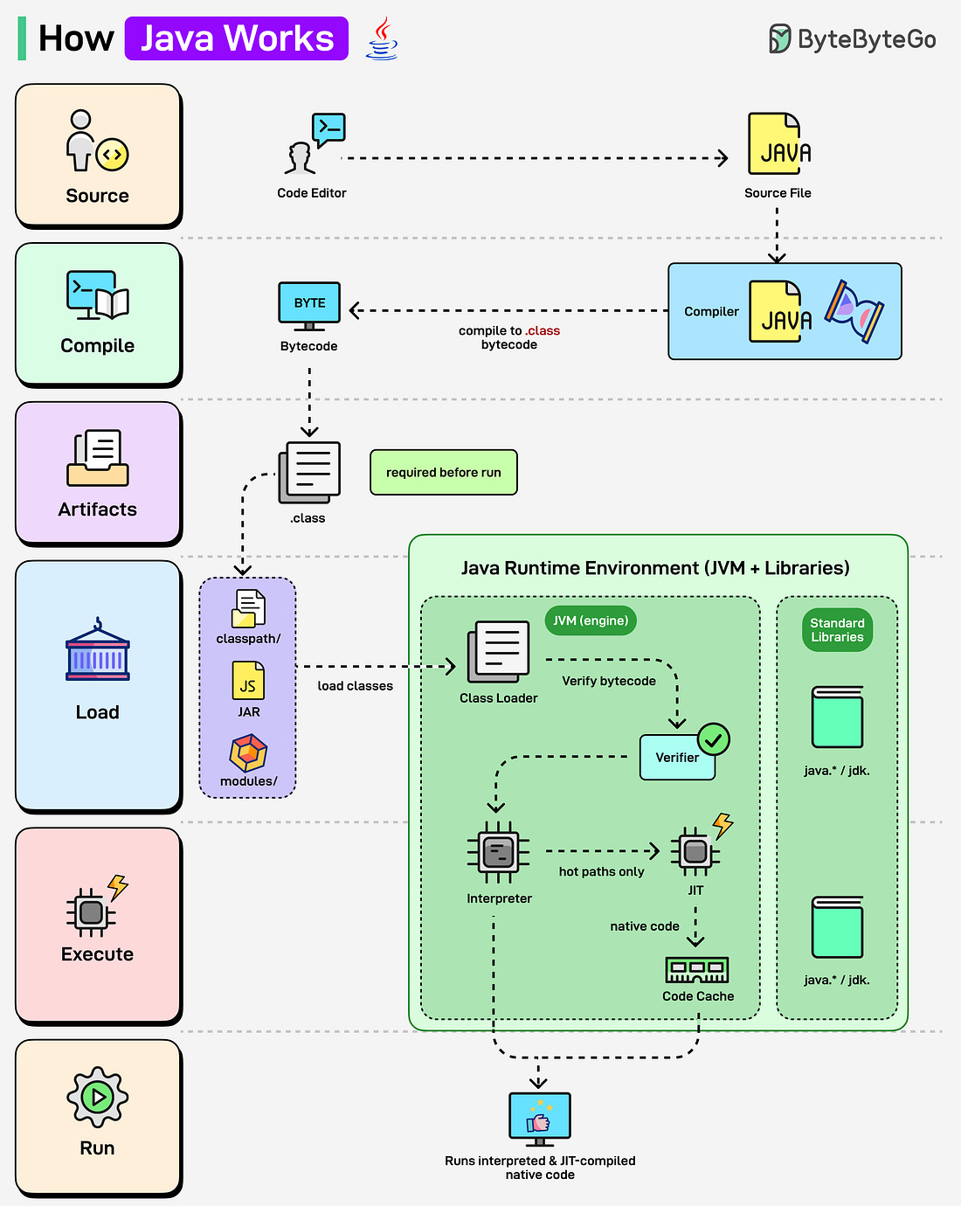

How Gitflow branching works –

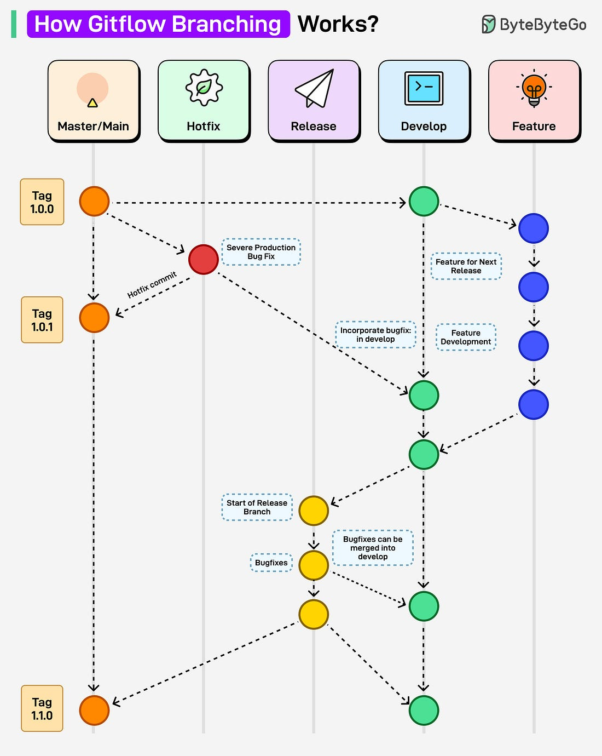

How RAG works –

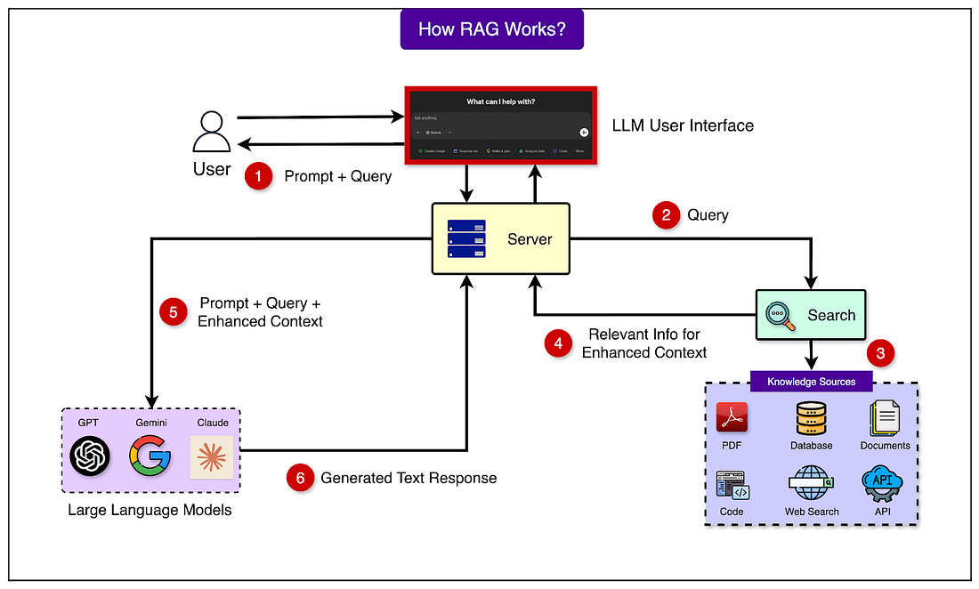

Stage 1 – preparation –

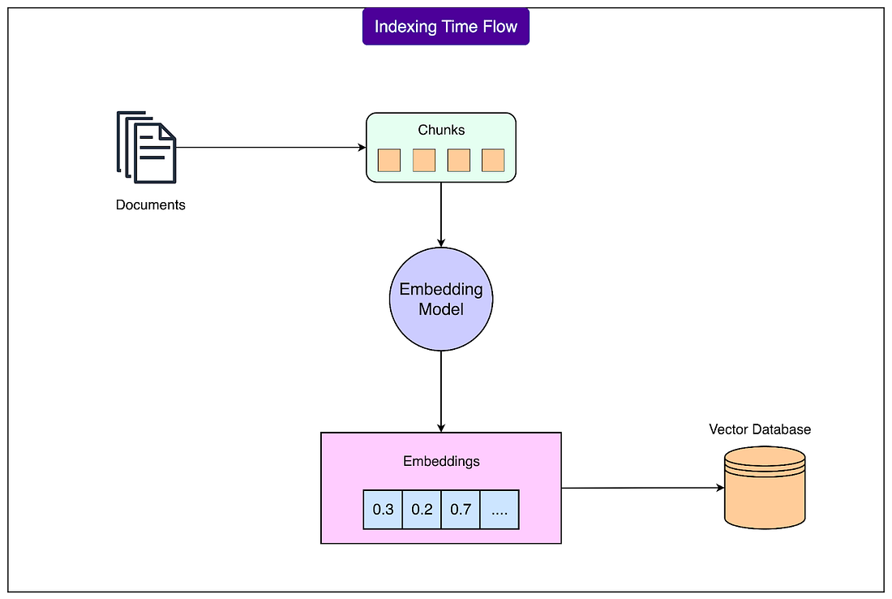

Stage 2 - User Query Processing

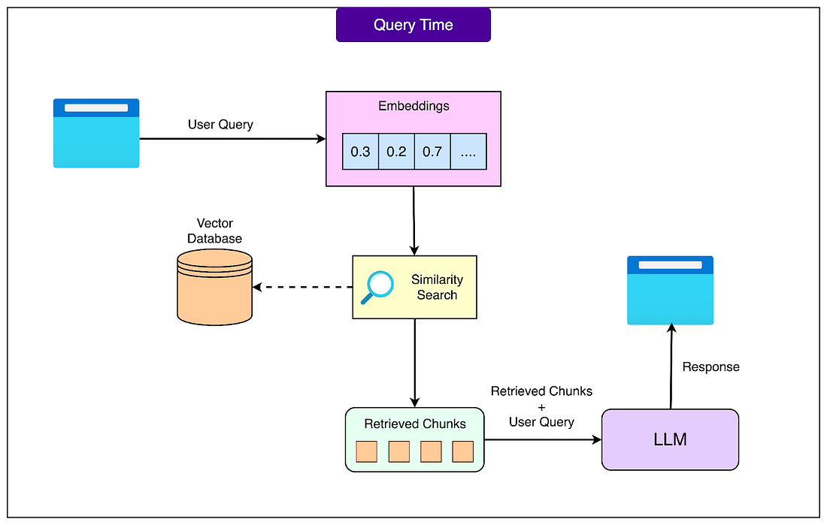

Embeddings –

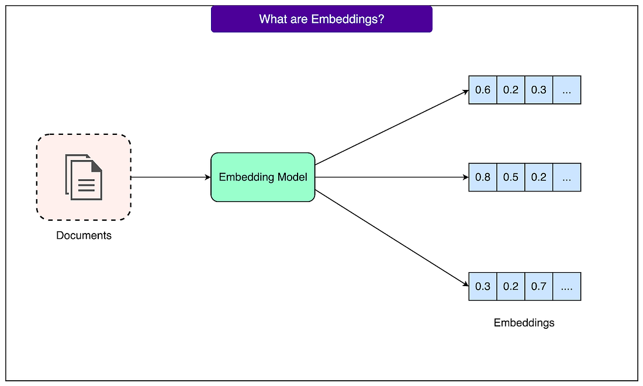

## Building chat system (WhatsApp, Facebook messenger, etc.)

Http for sending message, WebSocket for receiving message.

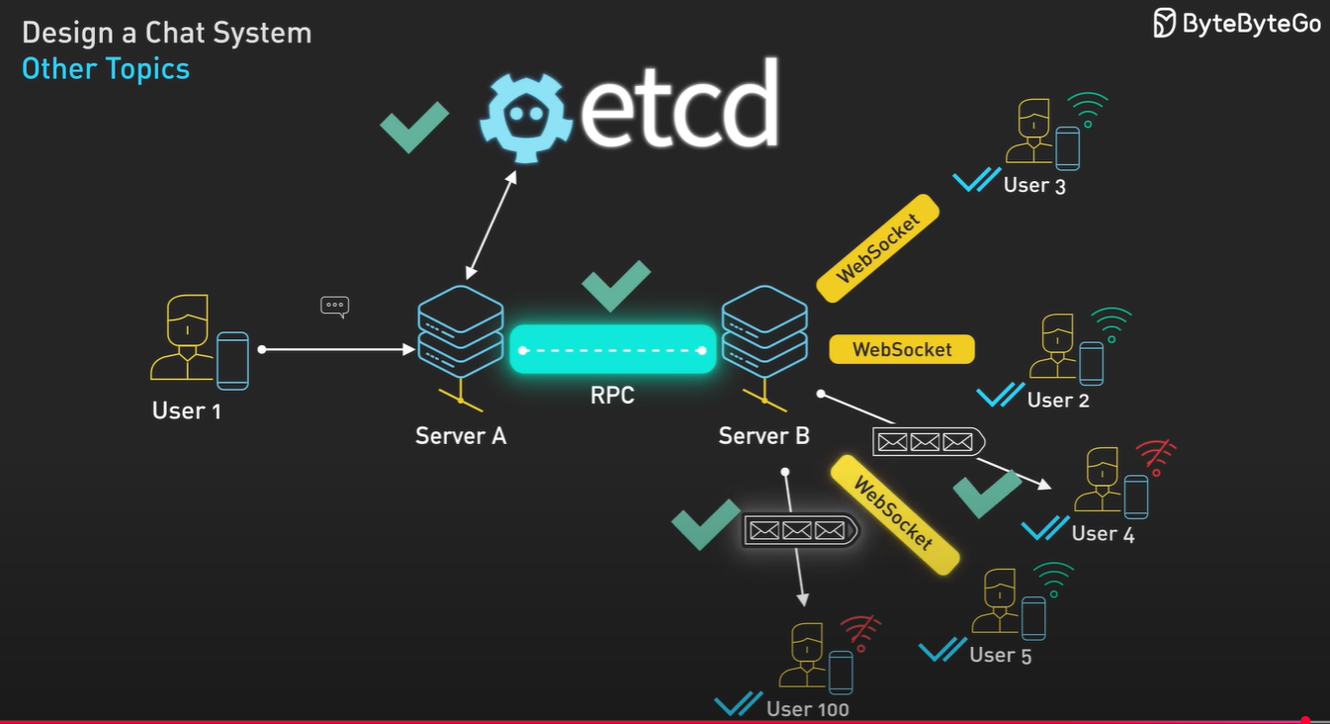

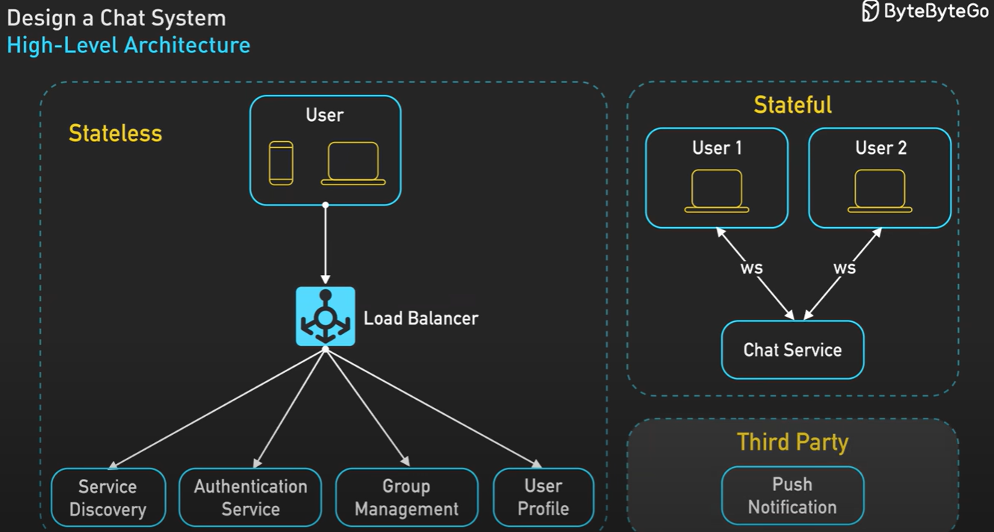

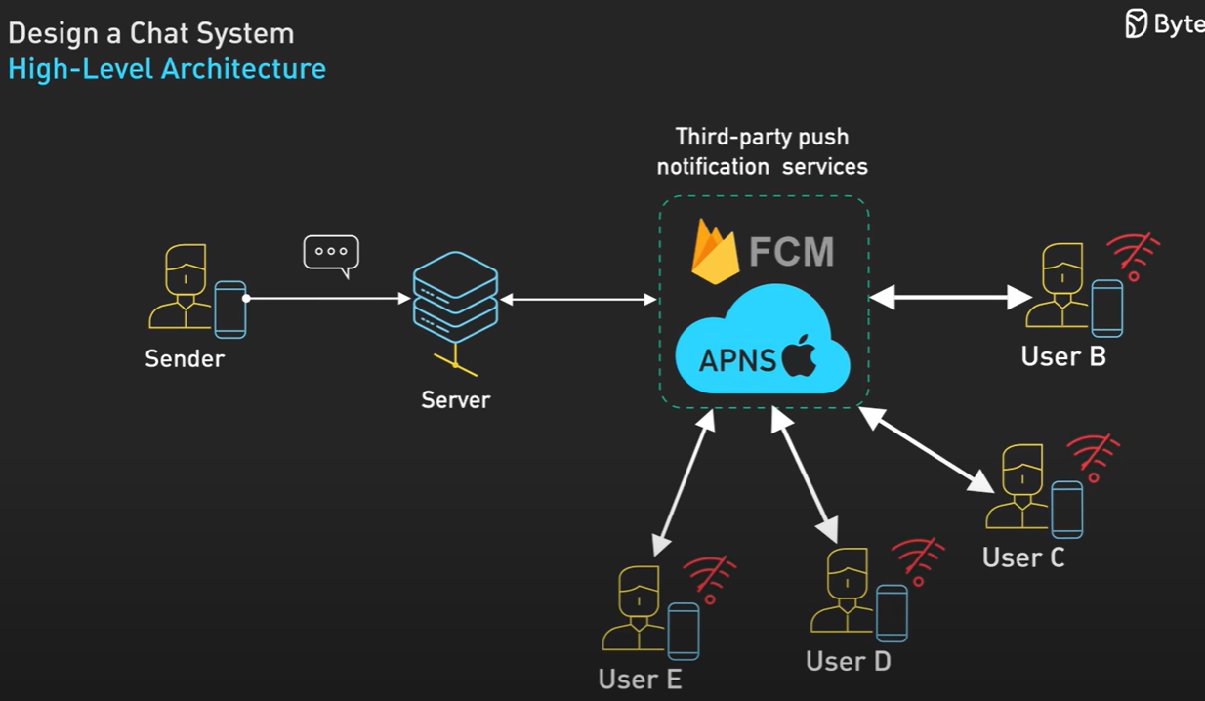

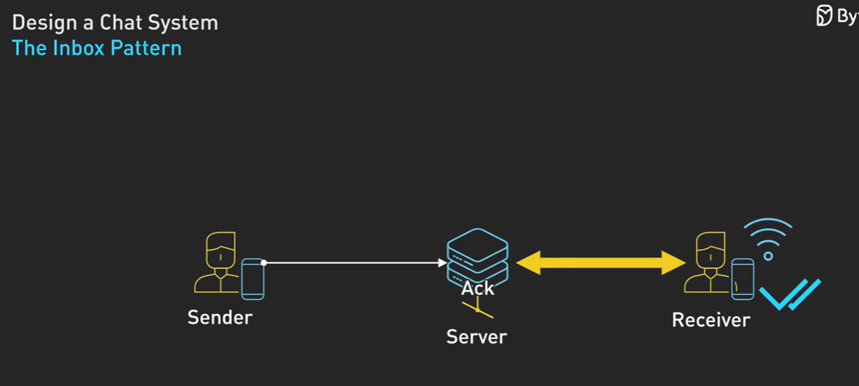

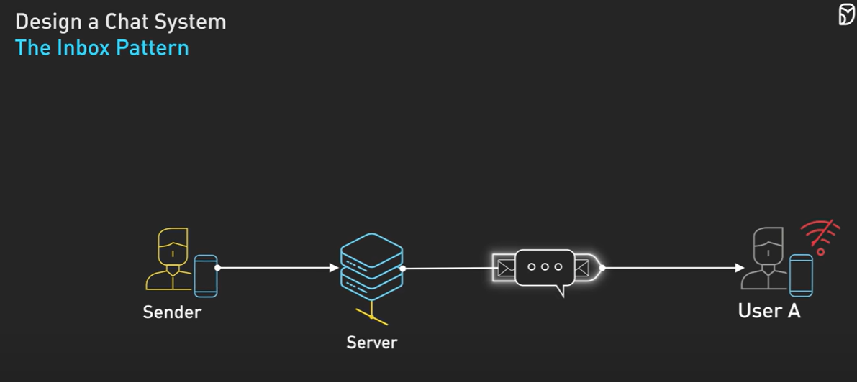

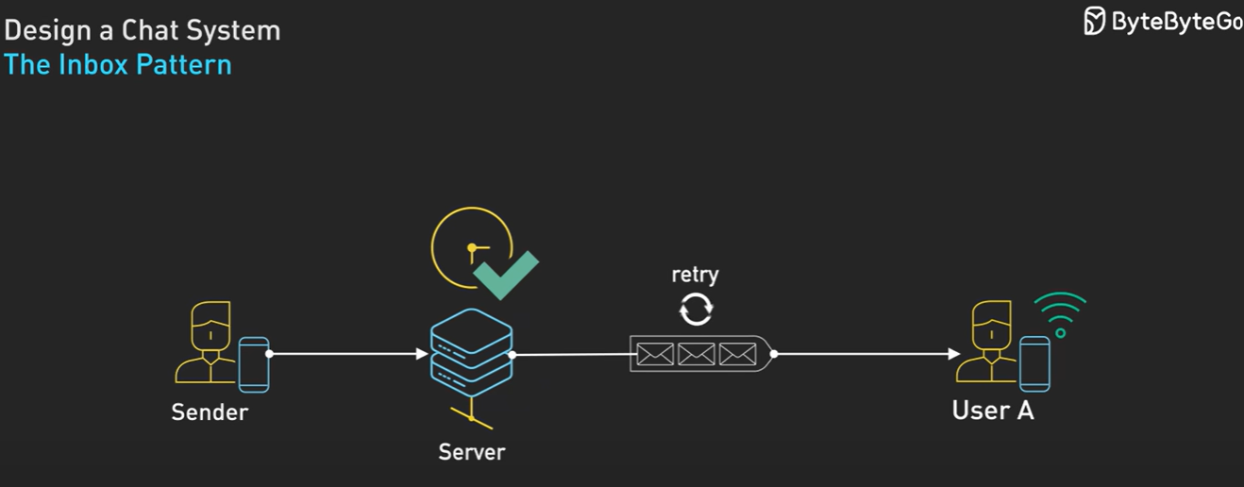

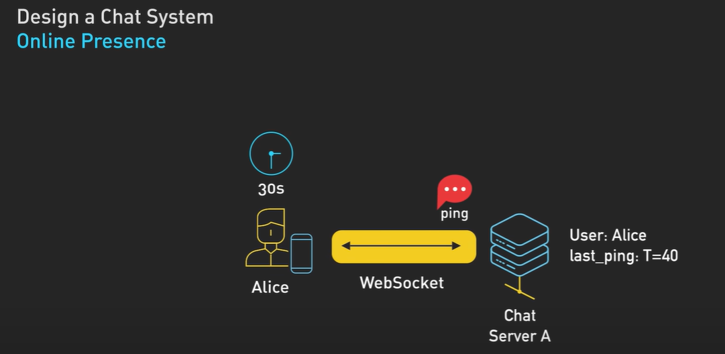

## Misc.

Wealthier Germans will generally be fitter and healthier, from a better diet and lower alcohol consumption. Upper-class people in Germany will make a greater effort to eat fresh fruit and vegetables, and to appreciate the cuisines of other cultures. The condition of their teeth will be unobjectionable, with no severe decay, etc.

If you are doing innovative work, bring new business to company by your ideas, have excellent team leaders, strong management qualities, if you can build new teams with mentoring them then in such cases you are beneficial to company and then age is no limit for working even after 60.